 | 

RET(Deployed) - Regional RET/TZ

AMST573: Functional Specification
Customer: DBS – IBG, CBG and T&M
.
Cust. ref: Order no. or other customer reference

Version: 1.8
Date: 15 Nov 2013

Document Sign-Off

Revision History

Revision Date | Version | Updated by | Summary of Changes
24 Sep 2010 | 0.1 | Li Chuang | First draft – consolidated all RET modules FS into one
25 Oct 2010 | 0.2 | Chris Wong | Update the latest requirements for:  - Deal Notification (Deal deletion handling)  - CN trading band  - Board Rate Sync (crossed via USD)
29 Oct 2010 | 0.3 | Chris Wong | Screen capture for RET demo
04 Nov 2010 | 0.4 | Chris Wong | Supplement for:  1. Board rate synchronization  2. CN Trading band  3. RFQ
21 Nov 2010 | 0.5 | Li Chuang | Updated customer profile upload and RFQ sections
25 Nov 2010 | 0.6 | Chris Wong | Updated the User Input Fields in RET Front end applet.
25 Nov 2010 | 0.7 | Anuja | Updated Customer Profile Import
26 Nov 2010 | 0.8 | Li Chuang | Updated RFQ error handling
2 Dec 2010 | 0.9 | Petrina Chong | Updated Chapter 3,4,5 and re-organise the document  Version release for T&M Regional Business Lead and BMS for feedback
2 Dec 2010 | 0.91 | Li Chuang | Updated after the discussion with Petrina
10 Dec 2010 | 0.92 | Li Chuang | Updated based on the feedback from FS walkthrough meeting
4 Jan 2011 | 0.93 | Li Chuang | Updated based on the feedback from project team
24 Jan 2011 | 0.94 | Li Chuang | Updated based on Adrian’ feedback
20 Feb 2011 | 0.95 | Adrian Chu | Include deal deletion workflow (section 3.2, 3.3 and 3.4)
11 Mar 2011 | 0.96 | Li Chuang | Updated section 5.2.4 and 6.1.4 based on user’s feedback
10 Mar 2011 | 1.0 | Adrian Chu | Final version for signoff  - This version does not cover the behaviour for customer search (for Chinse char) and the behaivor for Sales to perform the part for ‘Price quotation’
26 Oct 2011 | 1.1 | Max Lam | Updated HK solution Phase 1 – BRS
21 Nov 2011 | 1.2 | Chris Wong | Updated the email notification for CN/ID/TW. (Section 6.1.7)
30 Jun 2012 | 1.3 | Chris Wong | Updated HK solution Phase 2 & MLC revamp for Regional solution (TW/CN/ID/IN/HK)
22 July 2012 | 1.4 | Max Lam | Update the latest requirements for HK RET  Page 13: Added attachment for RFQ pricing requirement.  Page 25: session 5.2.4, Customer Profile Upload  Page 44: HK RET input fields
20 Sep 2012 | 1.5 | Li Chuang | Updated based on HK CBR
14 Jun 2013 | 1.6 | Li Chuang | Updated for China RIB requirement
15 Aug 2013 | 1.7 | Li Chuang | Updated RIBCN source system name to RIB
15 Nov 2013 | 1.8 | Corinne Loo | Updated India Phase 2 requirement

Sign-off List
Name | Department & Role | Signature | Date
Stanley LI | T&M Regional Rep, HK
Henry HO | T&M Regional Rep, SG
Linda KUO | T&M, Taiwan
Daphne HO | TMO, Taiwan
May GE | T&M, China
Kun XIANG | TMO, China
Stanley LI | T&M, Hong Kong
Stanley CHAN | TMO, Hong Kong
Patrick P. Aritonang | T&M, Indonesia
Christiati E Sianipar | TMO, Indonesia
Shrikant Somani / Arvind Narayan | T&M, India
T R Ramachandran / Indraneil Ghose | TMO, India
Jean Auyong | T&M, SG
Cheryl Lee | TMO, SG

Sign-off Notes
Name | Note

Using this template

Creating project documents
All project documents and records must be created in accordance with the Procedure for Managing Documents and Records (AMSP490).
This means that whenever you create a project document, you must:
- Identify the document owner and whether the document contains any pre-existing third party or Service provider intellectual property
- Display the correct signage, security classification and copyright notices on the document
Refer to the Procedure for Managing Documents and Records (AMSP490) for information about document ownership, intellectual property, signage, security classifications and copyright notices.

This is the format template for this document
Use this template to create a document when you have identified that the document owner. This template includes the correct signage, security classifications and copyright notices.
Note: If you have identified that the document owner is a customer, use the customer format template for this document (if one exists). Otherwise, modify the signage, security classifications and copyright notices within this template, as required

Modifying the content in this template
When you create a document using this template, you may tailor the content of the template, provided that you meet the intent of the relevant MS policies and procedures. This means that:
- Unless it is specifically stated that you may remove a section, do not delete any section from this template. Instead, mark sections “Not applicable”, as appropriate.
- You may add extra sections to this template, if required. Use the style “Heading 1, Topic Heading” for new section headings, and the style “Heading2, Topic Heading” for new sub-section headings. The headings will then be included automatically in the table of contents.
This template contains guidance and instructions in blue italic text to assist you to complete the details. When you complete the document content, delete this page, and all other instructional text.

Document-specific information relating to this template

Contents
1. Introduction 1
1.1. Purpose 1
1.2. Scope 1
1.3. Definitions, Acronyms and Abbreviations 1
1.4. Background 3
2. The Analysis Process 3
3. Business Process 5
3.1. Board Rate Publishing 5
3.2. Board Rate 6
3.3. Auto Quoted Rate 8
3.4. Manual Quoted Deal 10
3.5. Enhanced Auto Quoted Deal for HK (RFQHK) 12
4. Overall Description 14
4.1. RET as the Rate Publish Engine 15
4.2. RET as the FX Front-End Client 16
5. System Overview 17
5.1. System Features 17
5.1.1. Board Rate Publishing 17
5.1.2. Auto-Quoted Rate (RFQ) 20
5.1.3. Deal Input (Manual Quoted/Deal Deletion) 21
5.2. System Functions 22
5.2.1. Rates Parameters/Configuration 22
5.2.2. Deal Notification 24
5.2.3. Reports 25
5.2.4. Customer Profile Upload 25
5.2.5. User Management 26
5.3. Impact on the Present System 29
5.4. Security and Controls 29
6. Specific Requirements 30
6.1. Functional Requirements 30
6.1.1. Board Rate Publishing 30
6.1.2. Request for Quote (RFQ) – Auto quoted rate 32
6.1.3. CNY.USD Valuation – Trading Band 35
6.1.4. Customer Profile Upload 36
6.1.5. Interface to Murex – Deal Notification 38
6.1.6. Deal Input Customization – Trader Applet 42
6.1.7. Email Notification 44
6.1.8. Reports 2
6.1.9. User Authentication - Integration with AD 2
6.1.10. User Maintenance - Integration with AIM 4
6.2. Non Functional Requirements 4
6.3. Design Constraints 4
6.3.1. RET Interface Programs 5
6.3.2. RET TrAPI Constraint 5
6.3.3. Tomcat Server Constraint 5
6.3.4. Deal Notification 5
6.3.5. RET Reporting 5
6.3.6. Trader Applet Customization 5
6.4. Outstanding Items 6
6.5. User Documentation and Help System Requirements 6
6.5.1. Requirement One 6
6.6. Back-up and Recovery 6
6.7. Purchased Components 6
6.8. DR / BCP Requirements 6
6.9. System Interfaces 6
6.9.1. Board Rate Sync 7
6.9.2. RFQ Interface 7
6.9.3. CNY.USD Valuation – Trading Band 9
6.9.4. Customer Profile Upload 9
6.9.5. Interface to Murex - Deal Notification 10
6.9.6. Deal Input Customization – Trader Applet 10
6.9.7. Email Notification 11
6.9.8. AIM Interface 11
6.9.9. AD Interface 11
6.9.10. Reports 12
6.10. User Interfaces 12
6.10.1. Admin Applet 13
6.10.2. Trader Applet 14
6.11. Data Requirements 15
6.11.1. Data Requirement One 15
6.12. Reference Code Requirements 15
6.13. Archiving and Retrieval Requirements 16
6.14. Conversion Requirements 16
6.14.1. Data Group Name 16
7. Entity Relationship Diagram 17
8. Licensing Requirements 17
9. Applicable Standards 17
10. References 18
10.1. Procedures 18
10.2. Plans and schedules 18
10.3. Other references 18

Introduction
This Functional Specifications document identifies all the information required for Regional RET FX solution.

Purpose
This document describes the functional specifications of RET Interface programs.
The purpose of the functional specifications document is:
- To document the system behavior of the RET Interface programs to ensure they are in compliance with the customer's requirements.
- To get a common understanding on the RET Interface programs.

Scope
The scope of this document is to cover the following functionalities:
- RET Deal Notification which allows RET Manual Quoted deals to flow into Murex system via IP. Supported FX product types are VSD (i.e. Today), Spot, Forward, Swap, Time Option, Early Take-up (full/partial).
- Board Rate Synchronization which perform the board rate publishing from RET Rate Engine to other systems via IP.
- Request for Quotes (RFQ) service is a Rate Service which provides the FX quoted rate on demand to other systems that need a FX quoted rate for the FX transactions via IP. Support FX rate type is VSD (i.e. Today).
- Special RFQ called RFQHK will be built for HK solution to handle both Real-time Quoted rate & Board Rate requests from GBF & IPE. Supported FX rate type is VSD.
- Active Directory Integration enables users to login to RET front end by using their 1bank account.
- Customer data uploading based on the interface files received from Finacle.
- In HK, customer data uploading based on the interface files received from LRM Master file and IBG manual patch file.
- AIM Integration integrates RET staff account creation, modification & deletion with the bank standard ID management system called AIM.
- RET recon reports
- CN Trading Band control for Mainland China to trade USD.CNY.

Definitions, Acronyms and Abbreviations
The following table summarizes all the definitions, acronyms and abbreviations that are used in this document.

Definition / Acronym / Abbreviation | Expansion | Explanation (if any)
RET | Reuters Electronic Trading
RU | RU | Mainframe system to provide the rate update to TZ.
IP | Integration Platform | Strategic platform to interface with internal system to provide common services.
IMEX | IMEX | Trade service system (IBG)
Finacle | Finacle | Core Banking System (IBG/CBG)
TT | Telegraphic Transfer Rate
CS | Cash Rate
LCY | Local currency | Local Currency. For example,  In Taiwan, LCY will be TWD
FCY | Foreign currency | Non-local currency.
RFQ | Request For Quotes
AD | Active Directory | 1bank Active Directory Service. (e.g. reg1)
DN | Deal Notification Interface
BRS | Board Rate Synchronization Interface
GFU | Funding & Quotation
GBF | Branch Foreign Exchange
CT | Teller Terminal
IPE | Integrated Payment Engine
RN | Bills and Remittances System
FSSP | Funds Settlement
FRSP | Generic Payment/Receipt System
AVALOQ | AVALOQ
BNR | BNR

Background
Customer FX (for CBG and IBG customers) is currently handled differently in different locations for DBS.

For HK/China, FX is handled in GBF/CBF, it is a legacy system in the bank and there is no real-time position interface to Murex. Traders monitor FX position in the manual blotter. At the end of day, GBF/CBF will interface the position to Murex during the batch interface.

For Taiwan, FX is handled in Unisys/Finacle for BOWA and there is no real-time position interface to Murex. Taiwan T&M trader/sales need to manually input the position into Murex. The processes are manual and the relative operating error is high.

Similarly for Indonesia and India, there is no FX system currently.

FX Rate Publish for board rate Transactions
For HK/China, board rate FX is published in RU. This is not a real-time update system. Trader need to update the rate in RU, which subsequently broadcast to rate board for board rate FX transaction.

For Taiwan, T&M sends FX rate sheet to different units for FX indication. After Finacle final phase cutover, board rate FX is updated and published via Finacle manually by T&M trader. However, this is not a real-time update system.

Since the FX board rate is not real-time updated, the threshold amount for board rate transaction is relatively small.

There is no automatic tier pricing offered in the system. In case customer would like to get a tier price, it needs to call T&M sales for rate quotation.

Quoted rate Transaction
For transactions with amount larger than board rate threshold or customer requests to obtain a favorable rate, they need to call in T&M trading desk for rate quotation. RM or Ops manually input the rate for the transaction after confirm the rate.

The Analysis Process
Three major activities with respect to the analysis are as below:
- The information on the existing business processes and systems related with the required enhancements was gathered.
- The analysis of the requirements was done for the existing business/system processes and the customer required enhancements.
- The enhanced / changed functionality of the existing system is documented here as identified during analysis.

Business Process

Board Rate Publishing
This is an enhanced process. In this case, RET acts as a Rate Engine to pushing the tradable Board rates to other systems like IPE, Finacle, RU & IMEX. T&M will pre-configure the setup (e.g. Volatility Threshold) for all tradable Board rate CCY pairs in RET.

Note: | In any cases, T&M Dealer desk could have the rights to override any pre-configured rates in RET by adjusting the corresponding CCY rate in the monitoring screen inside RET Front End.
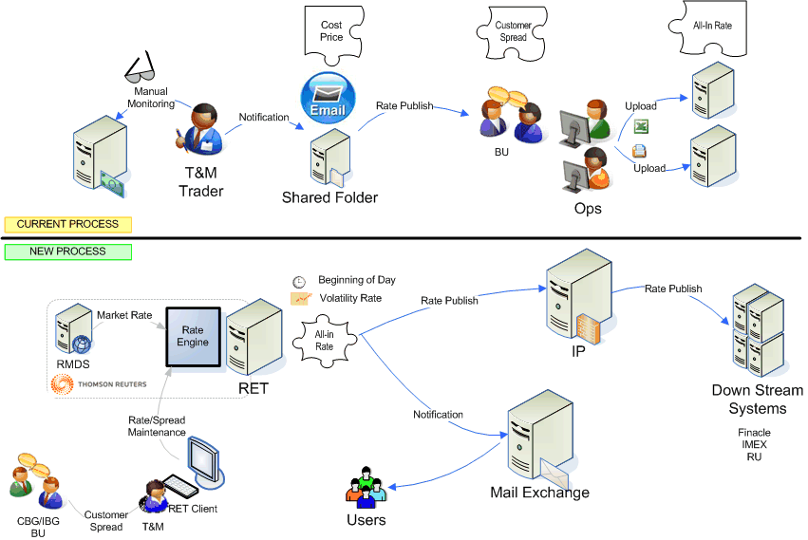

- An interface program called BRS will perform the checking on the latest rates published by RET periodically. If there is any change be detected, BRS will further publish the full set of latest Board rates to other systems. Otherwise, BRS will suppress the Board rate publishing.
- Other systems like Finacle, IMEX, IPE will capture this set of Board rates to do the Board rate deal at their front end.
- If the CCY is suspended for trading, RET will send out zero rate to all downstream system.
- For HK solution, if the CCY is suspended for trading, RET will send out last valid rate and suspended indicator to all downstream system.

If there is a typhoon hitting the north of TW to have typhoon holiday for the branches in the north of TW only, but the branches in the south of TW continue the businesses. The north TW branches will use the latest board rate published by RET after the typhoon holiday.

Board Rate
This is an enhanced process. RET is transparent in the process. The actual processing is handled in the regional TZ system. The workflow describes the end-to-end flow.
RET send the board rates to IP which then broadcast to downstream systems (e.g. RU, Finacle, IMEX & HK IPE). Downstream systems capture board rate transactions and interface board rate deals to TZ for processing. The detail information on interface and procedure will be provided by downstream systems.
If the board rate broadcast cannot reach other systems due to technical fault, the contingency plan will be executed.
- If the communication link between RET and IP is down, T&M trader will manually update the board rate and broad cast to branches by following the current manual board rate update process for each country
- If the RET production server is down, RET will switch to DR server. The RET BCP process will be activated.

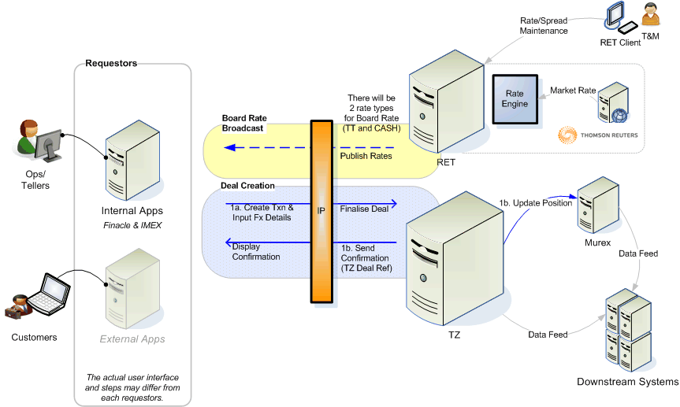

Below describe the workflow for deletion of Board rate deal

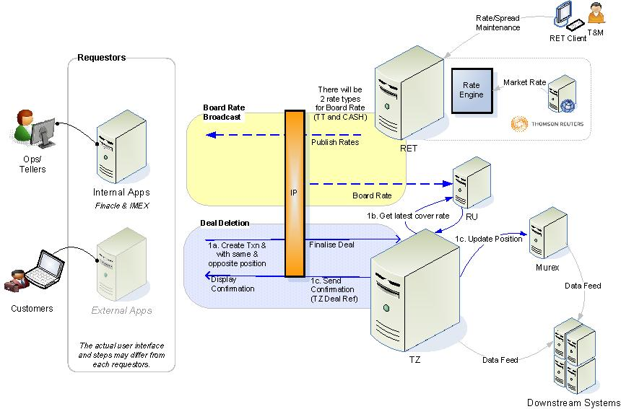
- CBG Ops/IBG Ops users/branch tellers reverse the board rate deal via downstream systems (e.g. Finacle)
- Board rate deal of same buy/sell amount but of opposite buy/sell direction (i.e. same and opposite position) will be passed to TZ
- TZ will create a new deal with same and opposite position with the same customer rate
- Latest cover rate (trader cost) will be retrieved from RU during the above process
- The position will be sent to Murex

Note: | For details of usage of downstream system functions, please refer to corresponding downstream system documentation for RET/TZ project (e.g. Finacle, IMEX)

Auto Quoted Rate
This is a new process. For system auto quoted deals, RET acts as a Rate Engine to provide the tradable close-to-market System Quoted rates to the Rate Requester. (e.g. Finacle/IMEX). The following diagram illustrates the system auto quoted deal flow through RFQ service.
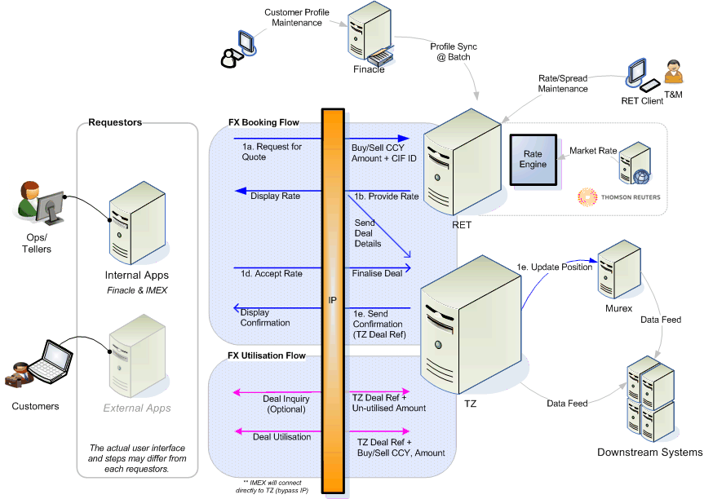

- Service consumer applications (e.g. Finacle/IMEX) send rate request to RFQ service
- RFQ service retrieves the requested FX rates from RET through auto-trading in RET
- RFQ service sends the cover rates to TZ with a unique rate ref no, rate expiry period as well as the rate quoted time.
- RFQ service sends all in rates (customer rate) to consumer applications (e.g. Finacle/IMEX) with the unique rate ref no, rate expiry period as well as the rate quoted time.
- The consumer applications accept the rate, books the deal, the deal was sent to TZ with rate ref no
- TZ verifies if the rate is expired based on the rate ref no and rate expiry period.
- TZ sends TZ deal reference number to the consumer applications.
- TZ deal is sent to Murex for final position.

Note: | For the System Auto Quoted deal with Multi-Channel support, each channel has different customer tiers/spreads, but there will be a constant spread applied to different channels across all customer tiers. The trader cost will be same for different RFQ channels.

Below describe the workflow for deletion of Auto Quoted (RFQ) deal

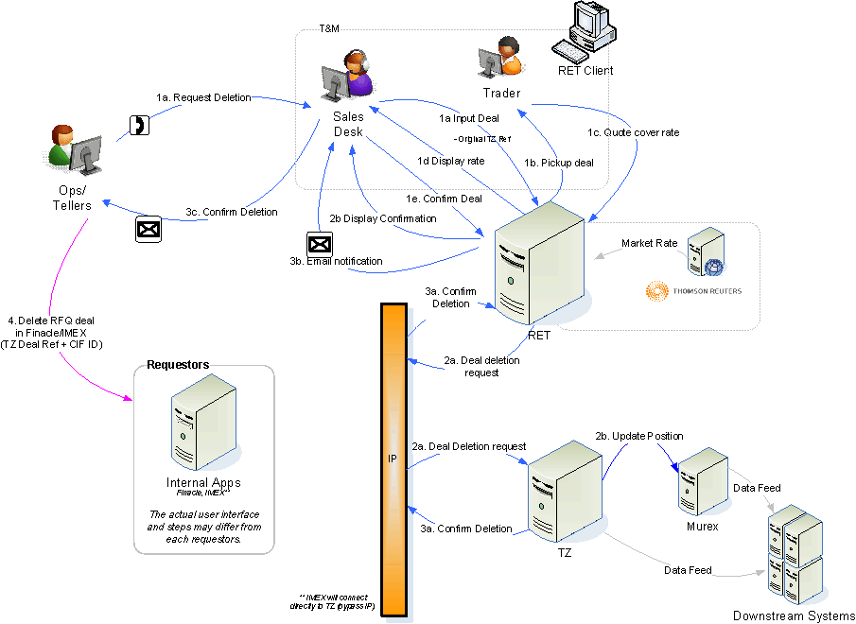

- CBG Ops/IBG Ops users/branch tellers call T&M Sales users to request for deletion of RFQ deal. Related information for the deal should be provided (e.g. CIF, buy/sell currency & amount, TZ reference number, value date)
- T&M Sales will input the deal via RET with indicate as deal deletion
- The deal will be passed to T&M Trader to provide the cover rate (trader cost)
- Then will pass back to T&M Sales to confirm the deal
- After the deal is confirmed, RET will pass the deletion request to TZ to process
- TZ will perform validation (e.g. if it’s an existing deal in TZ)
- When the TZ complete the deletion process, position will be passed to Murex (with the latest cover rate/trader cost but original customer rate in opposite direction)
- Email notification with be sent to T&M Sales to confirm the deal is deleted in TZ
- T&M Sales forward the email to the IBG/CBG requestor to confirm the TZ deal has been deleted successfully
- IBG/CBG requestor should delete the RFQ deal in Finacle
p.s. If the deal is not deleted in Finacle, exceptions will be shown on day-end reconciliation Finacle report as there is unmatch RFQ deal between Finacle and TZ

Note: | For details of usage of downstream system functions (e.g. Finacle), please refer to corresponding downstream system documentation for RET/TZ project

Manual Quoted Deal
This is an enhanced process. RET acts as both a Rate Engine and a FX Trading to allow users to submit the deals via RET front end (RET Client applet or Trader applet). The deals will be booked and logged inside RET. Such done deals will further pass to TZ and finally Murex for position monitoring.

The following diagram illustrates the Manual Quoted deal flow through RET.
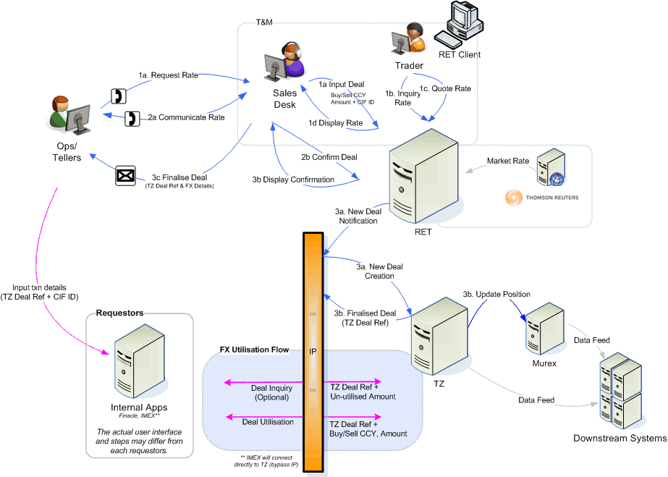
- For the large amount VSD deals or any amount of non-VSD deals including spot deals, forward deals and time option deals, OPS/Tellers have to make a phone call to T&M sales desk and request for the quotation.
- T&M sales will help to input the deal information (e.g. CCY pairs, Buy/Sell Amount…etc.) in the RET front end and submit the deal request to RET system.
For HK solution, IBG Ops, CBG TSM and T&M Sales are also allowed to input deal using RET front end.
- RET auto trader function will auto quote the rate to T&M sales for the deal amount less than the maximum amount for auto trader that is defined by T&M traders for different deal types.
- For the deal amount exceeds the maximum auto trader deal amount, T&M Dealers will pick up this deal quotation request and reply back the tradable price with consideration time to RET system. RET system will then route back this information to Sales desk.
- For HK, sales may use the Trader applet, and sales will input both trader cost/customer rates in RET.
- Once T&M Sales desk got the feedback from RET, he/she can get back the price and consideration time to OPS/Tellers. OPS/Tellers then can make the decision whether to reject or accept the deals. T&M Sales will help to perform the corresponding actions in RET front end.
Below describe the workflow for deletion of Manual Quoted deal
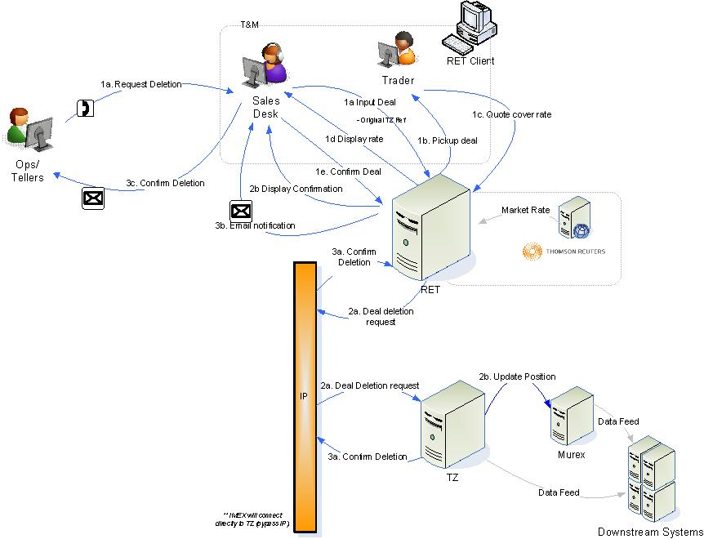

- CBG Ops/IBG Ops users/branch tellers call T&M Sales users to request for deletion of manual quoted deal. Related information for the deal should be provided (e.g. CIF, buy/sell currency & amount, TZ reference number, value date)
- T&M Sales will input the deal via RET with indicate as deal deletion
- The deal will be passed to T&M Trader to provide the cover rate (trader cost)
- Then will pass back to T&M Sales to confirm the deal
- After the deal is confirmed, RET will pass the deletion request to TZ to process
- TZ will perform validation (e.g. if it’s an existing deal in TZ)
- When the TZ complete the deletion process, position will be passed to Murex (with the latest cover rate/trader cost but original customer rate in opposite direction)
- Email notification with be sent to T&M Sales to confirm the deal is deleted in TZ
- T&M Sales forward the email to the IBG/CBG requestor to confirm the TZ deal has been deleted successfully

Enhanced Auto Quoted Deal for HK (RFQHK)
This is an enhanced process for HK legacy system. For system auto quoted deals in HK, RET acts as a Rate Engine to provide:
1. The tradable close-to-market system quoted rates
2. The tradable board rates to the Rate Requester. (e.g. GBF/CT/IPE).
Below describe the workflow of RFQHK:
- Service consumer applications (e.g. GBF) send rate request to RFQHK service via IP.
- RFQ will base on the request information to determine whether the board rate or quoted rate should be returned.
- RFQ service sends the cover rates to TZ with a unique rate ref no, rate expiry (if non-board rate) period as well as the rate quoted time.
- RFQ service sends all in rates (customer rate) to consumer applications with the unique rate ref no, rate expiry period & the rate quoted time with all the GBF Response Info (e.g. Reference board rates).
- The consumer applications accept the rate, books the deal, the deal was sent to TZ with rate ref no.
- TZ verifies if the rate is expired based on the rate ref no and rate expiry period.
- TZ sends TZ deal reference number to the consumer applications.
- TZ deal is sent to Murex for final position.

Note: | For details of RFQHK pricing requirement, please refer to attached spreadsheet below.  

Enhanced Auto Quoted Deal for China
The auto quoted or RFQ web service shall be enhanced to provide the retail internet banking customers a preferential rate which is different with the current production auto quoted rate. This set of rate is supposed to be better than production rate to promote the utilization of internet channel for external customers.
1. RFQ web service shall be able to provide the two set of rates for different channels. One set for internal users to quote the FX price for customers as per BAU, the other set is particularly for internet banking requests.
2. RFQ shall base on the source system name, RIB, to provide the rate for RIB and the current production rate for other source systems
3. The enhancement is for China only, will not apply to other regional centers.
4. The internet banking rate shall be setup in RET which is a different set of rate.
5. T&M shall provide the spreads for RIB rate
6. There shall be additional setup in RET for RFQ to subscribe two different set of rate based on the source system name in the request.
7. No change in the RET pricing method and any other common setting for currencies.

Overall Description
The solution is expected to handle the rate publishing module and provides an interface for the users to input the trade deal before submitting to Murex/TZ.

Note: Murex, TZ and RET are three different systems. RET is purely act as a front-end client to submit the deal. Please refer to the TZ Functional Specification for details on deal management.

The application is built on top of the API provided by RET and out-of-the box features from RET client applets. The subsequent section of this document will address how the requirements are delivered.

Below is a summary of the transaction flow
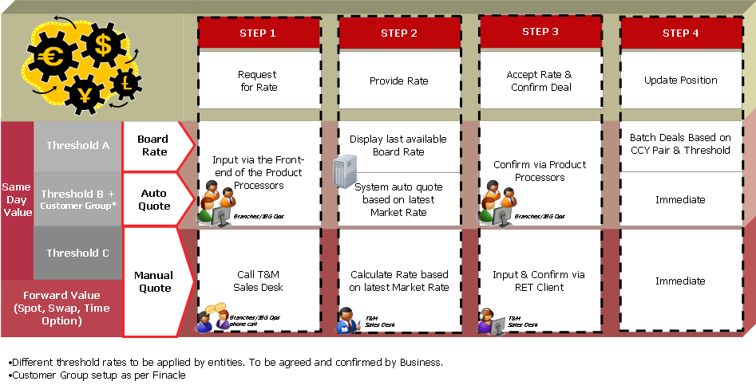

Note | As the Reuter’s API is not able to retrieve both the swap points and the market spot rate at one API call, there are two separate subscriptions to RET, one for market spot and one for swap point.  This may result that market spot rate and swap points are out of sync if the changes of the latter occurred just in between the first and the second API call, although it hardly happens that way.

RET as the Rate Publish Engine
There are 3 different categories of rates
- Board Rate : This will be provided via an interface program (BRS) and system interface through the existing DBS applications via the Integrated Platform (IP)
- Auto Quoted Rate: This will be provided through a web service call (RFQ) through the existing DBS applications via the Integrated Platform (IP).
- Manual Quoted Rate: This will be provided via the client login to RET applet.

The system will interface to Thomson Reuters to fetch the latest market rates and required parameters/configures then present the final rates to the users.

All parameters/configurations will be maintained via the Thomson Reuters standard user interface via the RET Admin applet unless specified.

The system will interface to the regional TZ system for the deal creation, credit limit checking and deal reversal.

The process for Murex bypassing the PCE limit chalking for RET manual quoted deals is as follows,
  - Users enter the “Bypass” in RET customized field PCE Override Auth Code.
  - RET will pass the field to Murex during the quoted deal creation.
  - Murex will bypass PCE limit chalking

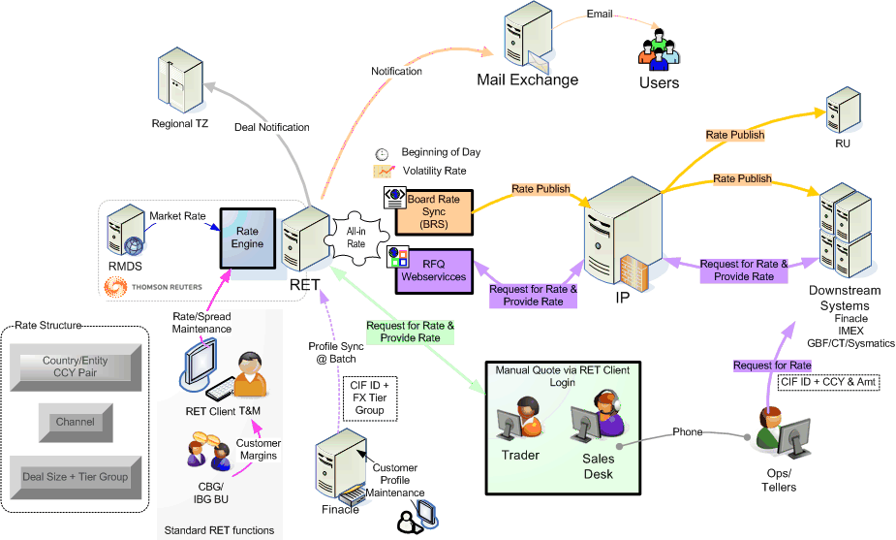

Figure ‎4-1 RET Rate Engine Overview

RET as the FX Front-End Client
Only the manual quoted deal will be performed via the web-based Reuter Client to input the deals to Murex.
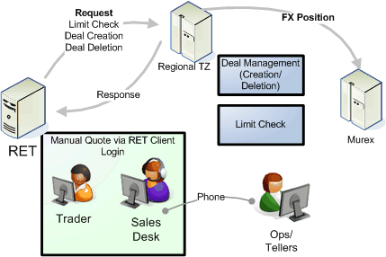

The users can submit the various deal types
- Value same day – New deal
- Value same day – Reversal deal
- Forward deal – New deal
- Spot deal – New deal
- Time Option deal – New deal
- Swap deals – New deal
- Early Take-up (full/partial) – New deal

The different FX deal input types in TW, e.g. 1. FX forward rollover (USD/TW1, G7) (currently T&M sales input a reversed spot deal and a new forward deal in Murex.), 2. FX spot extending as FX forward (G7 only) (T&M sales C&R the deals in Mx) and 3. FX forward/swap rollback for early termination (USD/TW1, G7) (T&M sales C&R the deals in Murex.), shall be still handled operationally in RET as what they are done in Murex.

T&M trader/sales can differentiate OBU and DBU when inputting deals in RET by choosing the OBU/DBU input field. But there is no function in RET to prohibit TWD for OBU deals.

System Overview

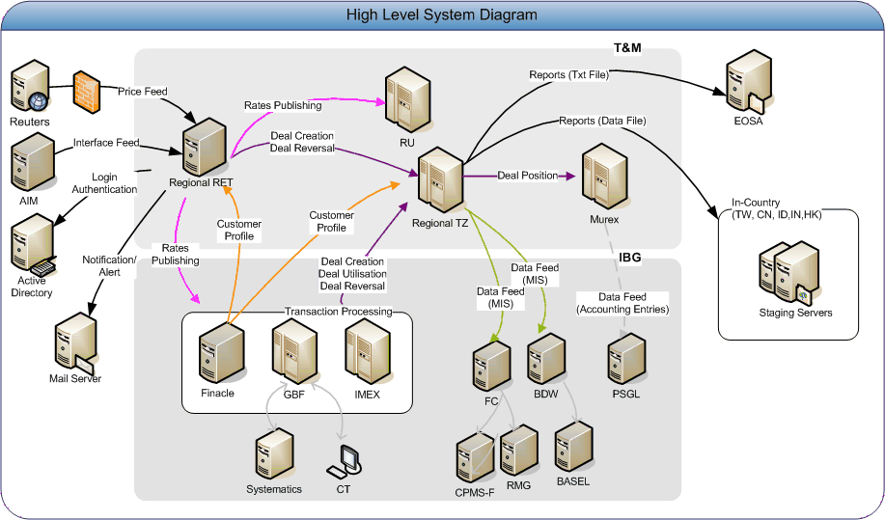

Figure ‎5-2 High Level System Diagram

System Features

Board Rate Publishing
A standard service will be made available via IP and IP will further push to the service subscribers. There are unique mapping of the individual fields done at the IP layer in conjunction to the service subscribers’ requirement. The respective service subscribers will upload to their database accordingly. The actual mapping to the systems will be covered in their respective functional specifications.

You may refer to the following documents for more details.
- RU “AHK-006620-AMS_FS_v1 for RU Regional“
- Finacle “Integration Functional Design (IFD) DBS Implementation for TZ-RET Interface”
- IMEX “Interface to Rate and FX System”

A new board rate will be push to the IP on the following conditions
- Beginning of the day (Actual timing to be defined by respective country T&M)
- Market movements beyond the volatility threshold by currency pair (To be defined by respective country T&M)
- Manual suspension of the currency by T&M. The latest board rate with suspended indicator will be sent to IP.
- Trader manual update the rate through RET
The entire list of valid currency pairs will be refreshed to IP even there is a single movement within the list. Whenever there is any change in the board rate, an email will be sent to a pre-defined user group and updated in the RET Board rate publishing webpage.
For HK, RET has rate suspend indicator and it will pass this indicator to IPE. When suspend indicator is ‘Y’, the most recent non-zero rates will be provided. All downstream system which use the rate may check the suspend indicator also. If value is ‘Y’, system should not use the rate and expect system can alert user with message like ‘Rate not available’.

Below is the proposed setup for the board rates for Taiwan, China & Indonesia.
Rate Type  Rate Codes | Buy | Sell
Telegraphic Transfer | TTB | TTS
Cash | CSHB | CSHS
For each currency pair, the last character setup in RET will refer rate type
Example:
USD.TWD Telegraphic USD.TWT
USD.TWD Cash USD.TWC

Below is the proposed setup for the board rates for Hong Kong. (Updated at 26-Oct-2011)
Rate Type  Rate Codes | Buy | Sell
Telegraphic Transfer | TTB | TTS
Big/Small Notes | NEB | NES
Demand Draft | DDB | DDS
For each currency pair, the last character setup in RET will refer rate type
Example:
USD.HKD Telegraphic USD.HKT with TT Modifier
USD.HKD Big/Small Notes USD.HKT with Big/Small Notes Modifier
USD.HKD Demand Draft USD.HKT with Demand Draft Modifier

The respective country has provided the list of currency pair to be setup for board rate during the information gathering exercise in Nov 2010.
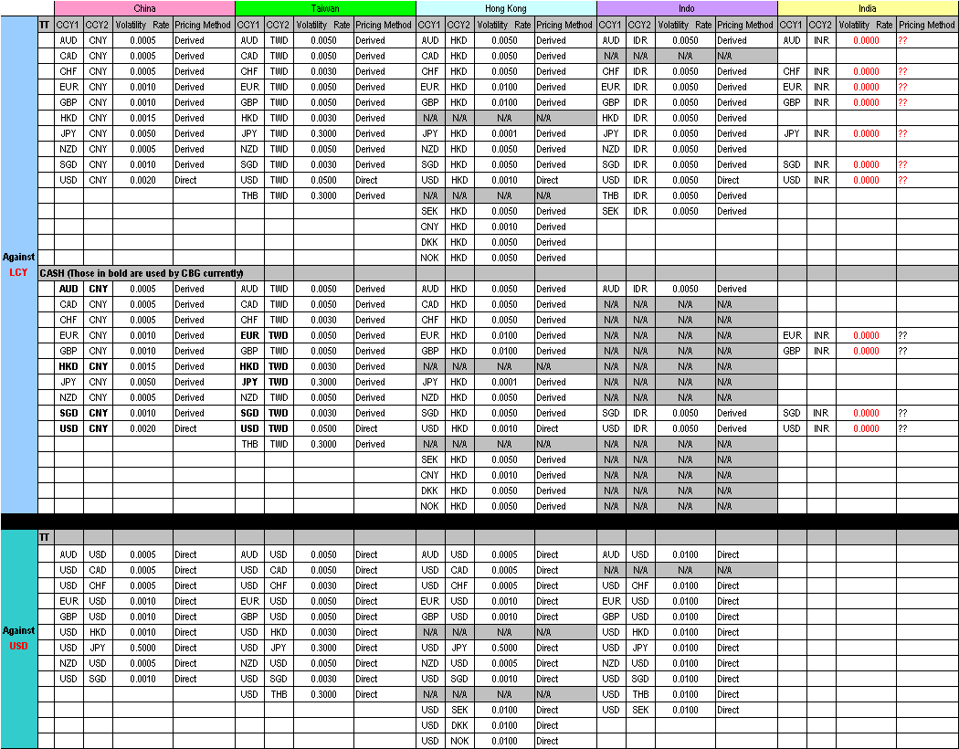

The actual direction of the currency pair will be determined based on the hierarchy configuration file. Below is the hierarchy sample configuration file gathered from country T&M BMS in Oct 2010.

Note | Any change in the hierarchy file from BMS will be done during the green zone via the technical request. This hierarchy file will be reference by T&M Systems only i.e. RET, TZ, Murex, RU. The corresponding downstream systems (e.g. Finacle/IMEX) hierarchy is maintained by the respective systems.  HK board rate stop at 6:30pm SGT

Hong Kong |  |  | Taiwan |  |  | China |  |  | Indo
CCY | Order |  | CCY | Order |  | CCY | Order |  | CCY | Order
EUR | 1 |  | EUR | 1 |  | EUR | 1 |  | EUR | 1
GBP | 2 |  | GBP | 2 |  | GBP | 2 |  | GBP | 2
AUD | 3 |  | AUD | 3 |  | AUD | 3 |  | AUD | 3
NZD | 4 |  | NZD | 4 |  | NZD | 4 |  | NZD | 4
USD | 5 |  | USD | 5 |  | USD | 5 |  | USD | 5
CAD | 6 |  | CAD | 6 |  | CAD | 6
CHF | 7 |  | CHF | 7 |  | CHF | 7 |  | CHF | 6
SGD | 8 |  | SGD | 8 |  | SGD | 8 |  | SGD | 7
JPY | 9 |  | JPY | 9 |  | JPY | 9 |  | JPY | 8
THB | 10 |  | THB | 10 |  | HKD | 10 |  | THB | 9
SEK | 11 |  | HKD | 11 |  | CNY | 11 |  | HKD | 10
DKK | 12 |  | TWD | 12 |  |  |  |  | SEK | 11
NOK | 13 |  |  |  |  |  |  |  | IDR | 12
PHP | 14
KRW | 15
TWD | 16
CNY | 17
HKD | 18

Auto-Quoted Rate (RFQ)
The system is capable to provide an auto quoted rate and it is termed as Request For Quote services through auto-trading in RET.

With the RET framework, the RFQ program provides the FX rate service to other systems and also provides the FX cover rates to TZ to calculate the sales margin. To speed up the RFQ response time for the FX auto quoted rate, RFQ shall not wait for the successful response from TZ before sending the customer rate to downstream systems. However, if some delay occurred between RET and TZ due to the network slowness, the auto quoted deals would have failed in TZ as TZ is not able to verify the rate if the RET rate had not yet arrived to TZ. There is no direct link from RFQ to those systems. Instead, all the system connections are through IP.

It is envisaged that the each entity will setup different deal sizes (amount tier) and different FX customer tier group for corporate clients and the groups for consumer customers. For each type (tier size and tier group) will need to be setup as an entry in the RET.

- The FX spreads including trader cost and customer spreads apply to RET user group level rather than individual customer level
- A process to be established to ensure the above mentioned point 1 when a new customer user group is created in RET.

Example:

Biz Unit | Deal Size  (max 6) | FX Tier Group  (max 10)
IBG | 10,001 to 50,000 | 1
IBG | 10,001 to 50,000 | 2
IBG | 10,001 to 50,000 | 3
IBG | 10,001 to 50,000 | 4
IBG | 50,001 to 75,000 | 1
IBG | 50,001 to 75,000 | 2
IBG | 50,001 to 75,000 | 3
IBG | 50,001 to 75,000 | 4
CBG | 5,001 to 25,000 | 9
CBG | 25,001 to 50,000 | 9
CBG | 50,001 to 90,000 | 9
CBG | 5,001 to 50,000 | 10

The system can apply either derived or crossed as the pricing method to compute the final all-in rate to requestors. This is defined at currency pair level by T&M
For the new customers who open the account today, this customer will not be available in RET in the same day since the RET customer information upload happens daily in the night as a batch job. The CT/GBF shall check and make sure the customer idendity is valid, RFQ shall return the rate in default tier so that the customer can proceed with a transaction.
Note: | For details of RFQHK pricing requirement, please refer session 3.5. RFQ HK cutoff time at 6:30pm

Deal Input (Manual Quoted/Deal Deletion)
The out-of-box RET client is used to serve this purpose with customization for the client/trader applet in order to accommodate capturing of the fields needed for regulatory reporting.

Each login to the RET client will requires a valid license connection. As such it was decided that only the T&M team will have access to the RET client.

The deal input via the RET client will then be updated back to the RET server and an interface program will format the deal to send to TZ. Refer to Section 6.1.6 Deal Input Customization – Trader Applet for detail of each deal type input.

For Hong Kong, dummy customers are used in two scenarios:
1. Walk-in customer without account in DBS (e.g. non-DBS customer come to DBS branch to exchange CNY Notes to HKD Notes)
2. New Customer created on today in Systematics request for FX transaction (new customer will only sync to RET and TZ system at day-end batch that will only effective on next working day)
TWO dummy customers will be pre-defined in RET and TZ system during the live cutover. One for Walk-customer and the other for new customers
1. For “Walk-in customer” scenario, front-end system (e.g. CT) passes blank CIS# to RET. RET system will return
- CIS# of the dummy walk-in customer
- Board rate FX Tier (pre-defined FX tier of the dummy customer)
- RFX Ind will be returned (pre-defined in dummy customer)
This scenario include the Bank own (self-use) FX transactions.

2. For “New customer” scenario, front-end system will pass CIS# of the customer to RET when request for rate, RET will return CIS# of the dummy customer to front-end when found the customer doesn’t exists in RET.
RET system will return
- CIS# of the dummy new customer
- Board rate FX Tier (pre-defined FX tier of the dummy customer)
- RFX Ind will be returned (pre-defined FX tier for dummy customer)
CT SHOULD allow user to input CFX / RFX indicator (xxx)
For the new customers who open the account today, this customer information is not be available in RET in the same day since the RET customer information upload happens daily at night as a batch job. A dummy customer shall be setup in RET so that sales trader is able to manually book deals for this customer and the real customer identity shall be entered in a custom field in RET deal ticket.

For India, T&M should be able to perform the following scenarios in RET:

  - For auto-mapping in Murex, traders is require to check the checkbox to indicate auto mapped, Murex will base on the indicator (auto) to create cover deals and customer deal and return MX reference to RET for successful deals.

  - Customer or Cover deal will be done manually in RET for the following scenarios:

  - Customer can lock the spot rate in the morning and confirm the swap points later in the day or vice versa.
  - Traders will select the CIS# to book the deal in RET. Murex will base on the CIS# and indicator (cust) to create a customer deal.
  - Traders will select from the three dummy CIS# (predefined in RET) to book the deal in RET. Murex will base on the dummy CIS# and indicator (cover) to create the cover deal in the Murex portfolio.
  - MX reference will be returned to RET for successful deals.

HK RET setup
- RET user account setup – corresponding client can seek corresponding trader for deal quotation.
- The corresponding RET clients or traders should access their related deals information only.
- RET client will be used by
    - CBG TSM: To book Board Rate and Auto-Quote deals
    - IBG Payment Ops, IBG Customer Service Centre and IBG Enterprise Treasury Management (ETM): to book Board Rate and Auto-Quote deals

RET FX Tier setup:

a. FX tier setup in RET for quoted rate deals.

b. IBG tier requirements are (see table below under “IBG” worksheet for more info):
1. Deal Type (Manual, Auto-Quote, Board)
2. Currency Pair
3. Segment (IBG1 – FIG, IBG1 – non FIG, IBG2, IBG3 – S&D, IBG3 – Pdt Team, IBG4)
4. Tier (1, 2, 3, 4, 5, 6)
5. Transaction Amount

c. CBG tier requirements are (see table below under “CBG” worksheet for more info):
1. Deal Type (Manual, Auto-Quote, Board)
2. Currency Pair
3. Tier (1, 2, 3, 4, 5, 6, 7, 8, Staff, Non-Package)
4. Transaction Amount
5. Channel (Remote, Manned) – Apply a fixed spread on top of the tier table based on requesting Channel for Auto-Quote

d. CBG and IBG Tier Requirement Table

System Functions

Rates Parameters/Configuration
In each region, the following parameters shall be setup by BMS, Trader and BU in RET:
Volatility Threshold setup(Trader) | Interbank Buffer(Trader) | Customer Spread setup(BU/BMS) | Customer tier setup(BU/BMS)
For Quoted deal, volatility threshold will be setup to minimum to allow the tradable FX rates publish out in real time manner | For each currency pair in each region, need to be setup inside the CCY Admin panel | For each currency pair in each region, customer spread need to be setup in Modifier: | Customer groups (6 x IBG & 2 x CBG)  Amount tiers

Reuters |  |  | Reuters  (Can be overrided by T&M - CCY Admin) |  |  | To be defined by T&M  (Via RET – CCY Admin) |  |  |  | Compute by RET |  | To be defined by IBG/CBG BU  (Via RET - Modifiers) |  |  | Final Rate displayed to Customer
Market Rate for SPOT |  |  | Market Rate for Forward Pt (i.e. Swap Pt) |  |  | Interbank buffer for SPOT |  |  |  | Trader Cost  (Cover Rate) |  | Customer Spread |  |  | All-In Rate
Bid | Ask |  | Bid | Ask |  |  |  |  |  | (Market Rate + Swap Pt + Interbank Buffer)

BMS teams should configure the setup in RET Admin Applet => CCY Admin Panel for each tradable currency pairs (including all the Quoted and Board rate currency pairs
The RET pricing method can be configured in for each pair that is published.
- Direct
  - Directly feed in from RMDS rate source, it is the USD based currency pairs
- Crossed
  - Via a selected currency, and via bid/offer or mid rates.
  - Rates are calculated before applying the spread
- Derived
  - The rates will be calculated after adding the spread in USD based currency pairs.
  - Much wider spread compare to Crossed method
- Note! After modifying any of the columns in RET CCY Admin, it is necessary to restart the RET EchoTRM process at backend servers in order for these changes to take effect.

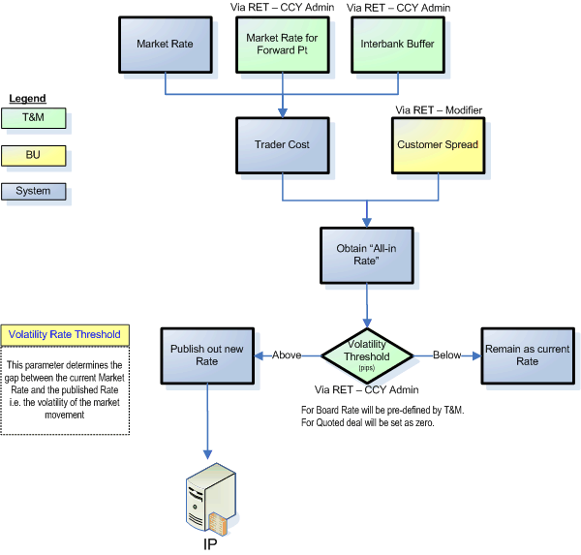

CNY.USD Valuation
Valuation of USD.CNY is currently defined based on the trading band based on the daily fix rate (middle rate) announced by the SAFE (State Administration of Foreign Exchange). The official trading band for the USD.CNY rate is set at +/- 0.5 percent instead of the de facto USD-peg.

The system will fetch the current market mid SPOT rates (CNY=CFXS) and the Fix rate (CNY=SAEC announced at 09:20am Beijing time in every morning) and monitor/controls of the final rate to be published to the downstream systems for board rate and auto quoted rate, however, there is no control on the trader manual quoted or system auto-quoted rate in RET for manual quoted deals.

The CNY trading band will be calculated at about 9:20am daily, if any deal is booked before 9:20am in the day, the previous day trading applies.

It is agreed by China T&M BMS to set the USD.CNY trading band
- 1% for TT rate shall be within the lowest bank buy rate and the highest bank sell rate, whereas
The lowest Bank buy rate = Fix rate (CNY=SAEC) * 0.995
The highest Bank sell rate = Fix rate (CNY=SAEC) * 1.005

- 4% for CASH rate shall be within the lowest bank buy rate and the highest bank sell rate, whereas
The lowest Bank buy rate = Fix rate (CNY=SAEC) * 0.98
The highest Bank sell rate = Fix rate (CNY=SAEC) * 1.02

Note the TT and CASH rates are board rates, the control of the trading band will be in RET board rate sync program and TZ board rate tolerance limit check during the board rate deal creation.

- 1% for Auto-quoted rate shall be within the lowest bank buy rate and the highest bank sell rate, whereas
The lowest Bank buy rate = Fix rate (CNY=SAEC) * 0.995
The highest Bank sell rate = Fix rate (CNY=SAEC) * 1.005

Note the auto-quoted rate control will be done from RFQ service that has been built out of RET.

Note | The trading band threshold will be maintained via a configuration file and updated by the technical team during the green zone. The new updates will take effect after the program restart.

It is confirmed in meeting that RET will allow manual quote trade input exceed the CNY trading band. However, RET will pass the trading band information to TZ through a file, TZ will then generate the exception reports for those deals that exceed the trading band accordingly.

Deal Notification
There are 3 types of deal message will be exchanged between RET, MLC & Murex and they are:
1. Credit Limit Checking Request/Response (vs MLC)
2. Deal Creation Notification/Response Update (vs Murex)
3. Deal Reversal Notification/Response Update (vs Murex)
The deal reversal will interface to Murex as a deal deletion.
T&M can input the deal purpose or deal remarks field to indicate FX forward rollover deals and reversal spot deal
There will be an interface program to read the messages from RET and package it accordingly to IP format.
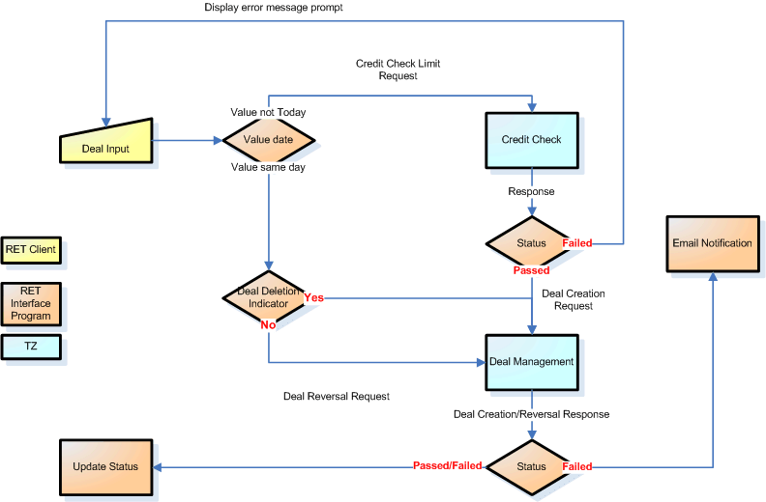

Reports
RET reporting module will create a report for all the deals created in RET for the day and to be sent with Murex for reconciliation purposes at pre-defined intervals. To be configured as TWS jobs.

The actual timing will depend on the frequency of the reports to be generated from Murex. It is currently defined as 1600 hrs and 1800 hrs Singapore time. To be finalized during the UAT for the respective entity.
For SG, CN and HK, a RET audit report shall capture all RET admin changes through admin applet. The users who needs review audit reports shall receive two emails, one is the audit report; the other one is the password to open the audit report.

Customer Profile Upload
Counterparty information is needed for T&M sales to book trades on behalf of the counterparties as well as lookup the FX Tier Group for each customer to determine the preferential rate. However, RET client search function is not able to handle more than 20k customers with a reasonable response time. Therefore, a separate customer search function shall be built outside of RET. It shall be activated from the RET deal ticket, and the customer search results shall populate into the customized fields in the deal ticket.

The search fields for Singapore and regional are different because Singapore gets the customer information from CIS while the regional gets the customer information from Finacle. For HK solution, RET gets the customer information from Systematics/LRM.
 | Singapore | Regional | HK
Search Fields | CIN  Mnemonic  Name  Account | CIF  Customer Name | CIS  Customer Name

As most of the HK, TW and China customer names are in Chinese, the customer search screen shall support Chinese character search. However, RET does not support Chinese characters, Chinese customer names will not be able to shown in RET applet except the customized fields in deal ticket.

To automate the process of counterparty creation in RET, by synching with Interface file from Finacle. New customer profile upload program needs to be built to cater for the following changes:
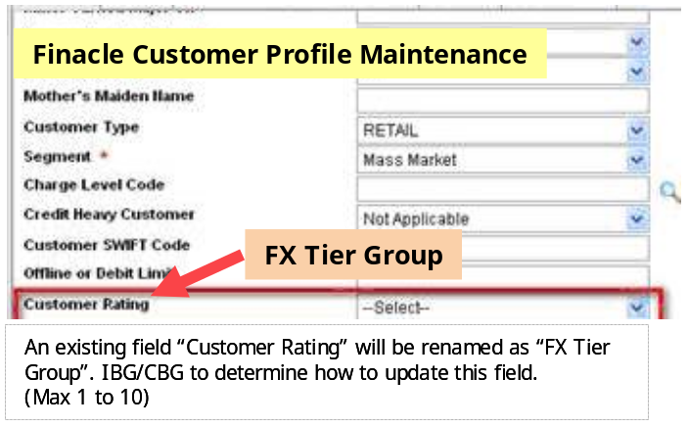
The dummy account customers will be setup in Finacle to handle walk-in customer or customer created only today and not yet interface from FINACLE to RET.

User Management
There are two different login types to RET system.
- Online through the browser (Internet Explorer) via single URL for each entity.
  - There will be 3 different interface based on the user access rights and permission after the login
    - Client applet
    - Trader applet
    - Admin applet
- Background Service for each entity.
  - There will be a proxy client (functional ID) to serves and response to the requestors for an auto quote request

The usage of RET applet may various across countries and is listed as follows:

Applet Type | Default | HK | TW | CN | IN | ID
Client Applet | Sales Desk | Sales Desk | Sales Desk | Sales Desk | Sales Desk | Sales Desk
Trader Applet | Trader | Sales Desk, IBG Ops, CBG TSM etc… (for quote rate during manual quoted deal creation only)  Trader Desk (other feature, e.g. suspend rate) | Trader | Trader | Trader | Trader
Admin Applet | BMS | BMS | BMS | BMS | BMS | BMS
Remarks |  | Sales team does not require to login separate RET applet.  All related feature using by them will be accessed in the same RET applet login.  Details will be provided by RET team in the RET FS

The diagram below provides the overview of the entire user administration.
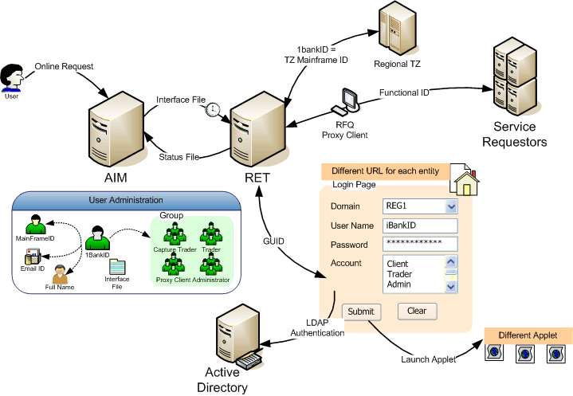

Figure ‎5-3 User Administration

Integration with Active Directory (AD)
RET is a new system in DBS. In this Regional RET-TZ project, EAS team request us to build a new interface to our 1bank Active Directory for the user authentication when logging in the RET system.

Integration with Automated Identify Management (AIM)
Based on the new regulation from ID Management, all systems are required to integrate with the AIM system to automate the DBS staff access rights in the various systems. Any user access rights to RET will then managed via the online application.

Impact on the Present System

No | Item | Current | Future
 | Customer Rate | T&M traders provides the cost price of the rate to BU  T&M sales/Respective BU may adjust the rates before upload or communicating to Customers | Customer spread/margins are maintained via RET as a single source.  This should be agreed between T&M and BU then setup via the RET Admin applet.
 | Board Rate Publish/Upload | Manual broadcast of the rates and upload into the respective systems. | All-in rates will be provided online from RET and automatically upload into the service subscribers’ application.
 | Quoted Rate | Manual phone call to T&M Sales desk to obtain the rates. | Provision to allow operation users to initiate an online request as auto quoted of a defined deal size on behalf of the T&M Trader. This is through RFQ service.
 | Forward Deals | Deals are booked directly in Murex | Deals can be booked via RET to TZ
Note for current situation, we have different practice for different locations.

Security and Controls
RFQ will make use of IP features on the security and controls.

RET uses LDAPS (Secured LDAP) to perform the AD authentication.

The program will login to RET via AdminAPI provided by Thomson Reuters. A system interface user’s ID/password needs to be created in order to login to RET. This login password should be in encrypted format. The program should have the ability to decrypt the password and login to RET.

Specific Requirements

Functional Requirements

Board Rate Publishing
The interface program will facilitate the rates provision for Telegraphic Transfer (TT) Buy/Sell and Cash Buy/Sell rate type within list of currency pair setup in the system. Note: There is no middle rate provided.
- Special CCY name handling:
- For Board TT rates of crossed CCY, the CCY name defined in RET will be either XXT.YYT or XXT.USD or USD.XXT.
- For Board CS rates of crossed CCY, the CCY name defined in RET will be either XXC.YYC or XXC.USD or USD.XXC.
- For Board CS, TT, Note rates of crossed CCY, the CCY name defined in RET will be either XXB.YYB or XXB.USD or USD.XXB
- This interface program should translate all the non-standard CCY name in RET to standard CCY name.
- e.g.
- Translate EUT.USD => EUR.USD (SPOT based CCY)
- Translate EUT.TWT => EUR.TWD (TT per LCY case)
- Translate EUC.TWC => EUR.TWD (CS per LCY case)
- Translate EUT.JPT => EUR.JPY (TT of crossed CCY case)
- Translate EUC.USD => EUR.USD (CS of crossed CCY case)
- Board rate sync Interface program need to calculate the inverse rates if necessary.
- e.g. Retrieving the FX bid rate of EUR.TWD (e.g. 40.53) from RET. Publish both bid rates of EUR.TWD (40.53) & TWD.EUR (1/40.53) to DS.

Purpose of the Function
To provide the FX board rates to DS for creating Board Rate deals and calculating Sales Margin.

Input
To retrieve  FX board rate details via RET API called TrAPI: | Trader cost of FX TODAY rates of SPOT based CCY. (i.e. Market Spot + Today Swap points + Interbank Buffers)  Board rates of FX TODAY rates (TT and CS ONLY) of both per USD or Crossed CCY pairs (i.e. Customer all in rates after customer spreads applied).  Note: Please note that FCY.LCY or LCY.FCY is treated as one type of Crossed CCY pairs.
To retrieve  FX board rate spread details from database: | Customer spread for both TT and CS board rates with different amount tiers. (i.e. corresponding Modifier details in RET)  Note: Customer Spread only applied to per USD pairs.  Note: Amount tiers are all calculated in USD equiv.  For example, in order to get the customer spread of Taiwan TT rate of EUR.TWD with amount tier “less than 10K” (USD equiv), there will be a corresponding Modifier called “TW.ALL.1-10000”.
To retrieve the hierarchy table from a plain text file: | Here is the hierarchy sample configuration file:  

Processing Logic and Conditions
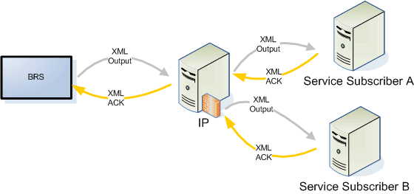

This interface program will only send 1 consolidated XML message to IP at each occurrence. IP will further to broadcast the FX rate details to service subscriber. IP will send back a single response message to notify whether the last broadcast is successful or not.

There will be three scenarios for the response message handling:
- Response message with success return code. (i.e. message successfully broadcast to IPE, RU, AVALOQ, IMEX & Finacle.) Logged the response in log file and kick start next cycle.
- Response message with application error or warning. (e.g. message unable to broadcast to any one of DS) Logged the error message in log file and send mail notification to support team or users. Kick start next cycle.
- Fault message returned. (e.g. message unable to broadcast to ALL DS or IP system failure). Logged the error message in log file and send mail notification to support team or users. Kick start next cycle.

Outputs
Board Rate update to downstream systems (IPE, AVALOQ, RU, IMEX & Finacle). Details fields are as below:

XML with the following FX rate details:
Trader cost of FX TODAY rates of SPOT based CCY pairs | x-ref: In the section of <op:SpotRateDetl> in IP XML layout.
Board rates of FX TODAY rates (TT and CS ONLY) of both per LCY or XCY. | x-ref: In the section of <op:BoardRateDetl> in IP XML layout.
Customer spreads for both TT and CS Board rates with different amount tiers. | x-ref: In the section of <op:BoardRateSpreadDetl> in IP XML layout  <Obsolete>
Hierarchy table. | x-ref: In the section of <op:CurHierarchyDetl> in IP XML layout.

Request for Quote (RFQ) – Auto quoted rate
The RFQ web service will be developed as a Java Web Service and running on the Apache Tomcat 6 server.

Purpose of the Function
RFQ (together with RET) provides the FX rate service to other systems like Finacle, IMEX, IDEAL3, IPE…etc. And also provides the FX cover rates to TZ to calculate the sales margin. However, there is no direct link from RFQ to those systems. Instead, all the system connections are through IP.

Important: RFQ FX rate service is for providing FX rates to the other systems. Deals are booked in other systems instead of RET.

For RFQ, it needs to query the RET Rate Engine to get the quoted FX rate or query the RET DB table to get the board rate. The following RET configurations are required for RFQ to work, these configurations will be on the basis of country.
- A RFQ proxy user to login to RET
- Create a dummy RFQ client for entity

Sample Messages

Web Service WSDL file | Request | Successful Response | Failed Response

Input
RFQ receives the FX rate request from service consumer systems. As a web service the protocol between the IP and RFQ is SOAP over HTTPS. The source systems or service consumer applications need to provide the following parameters to get the FX rate they required.

Example for Regional RFQ:

Field Name | Sample value
Source System Id | FINACLE
Request ID | FNCL-00001
Buy Sell Indicator | B or S
Dealt Currency | USD
Other Currency | JPY
Customer CIF (TIN for HK) | 10001
Dealt Amount | 15000
Rate Type
Tenor | TODAY

Processing Logic and Conditions
The following diagram shows the high level message validation for RFQ. The RFQ rate has the same timeout as manual quoted rate defined in RET.

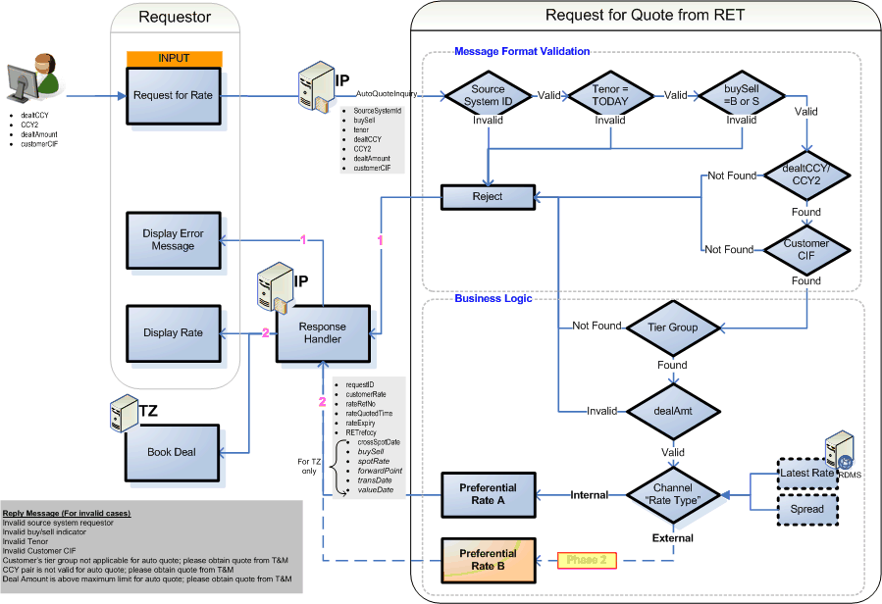

Figure ‎6-4 RFQ Logic Diagram

Outputs

Success Response
Upon receiving the request, RFQ retrieves the required FX rates and response back with the cover rates and customer rates. The IP will then dispatch the cover rates to TZ and customer rates to the consumer applications, e.g. Finacle.
The following table depicts the RFQ response and highlights the response fields to TZ or consumer applications.

EMS Tag Name | Usage | Value / Transformation Rules
<soap:Envelope xmlns:soap="http://schemas.xmlsoap.org/soap/envelope/"> | M
<soap:Body> | M
<ns2:getFXrateResponse xmlns:ns2="http://service.FXrate.dbs.com/"> | M
<return> | M
<requestID> | M | e.g. FNCL-00001
<customerRate> | M | 1.23
<rateRefNo> | M | 10001
<rateQuotedTime> | M | HH24:MM:SS
<rateExpiry> | M | 30 (Seconds)
RETrefccy | M
<crossSpotDate> | O | To TZ only
<TZInfo> | occurs twice
<buySell> | M
<spotRate> | M | 1.21
<forwardPoint> | M | 0.01
<valueDate> | M | Yyyymmdd
</TZInfo>
</return> | M
</ns2:getFXrateResponse> | M
</soap:Body> | M
</soap:Envelope> | M

Failed Response
If there is any exceptions during the RFQ processing, e.g. the request is invalid or the requested FX currency is not supported RFQ, the RFQ will return the SOAP fault back to the source systems.
The following table describes the RFQ failure response.

EMS Tag Name | Usage | Value / Transformation Rules
<soap:Envelope xmlns:soap="http://schemas.xmlsoap.org/soap/envelope/"> | M
<soap:Body> | M
<soap:Fault> | M
<faultcode> | M | e.g. soap:Server
<faultstring> | O | Fault occurred while processing
</soap:Fault> | M
</soap:Body> | M
</soap:Envelope> | M

CNY.USD Valuation – Trading Band
Adhere to the China Central Bank “People Bank of China” requirement on the CNY.USD valuation with trading band.

Purpose of the Function
To cater for the CN trading band requirement in mainland China.

Input
USD.CNS: The market raw data of CNY=CFXS coming from RMDS.
USD.CNI: The market raw data of CNY=SAEC coming from RMDS.

Processing Logic and Conditions
The difference between customer all in rate and the Interest rate (CNY=SAEC announced at 09:20am Beijing time in every morning) cannot be larger then 1% for TT/Quoted and 4% for Cash. In case of breaching, bid of SPOT will be Interest rate – 0.5%/2% and ask of SPOT will be Interest rate + 0.5%/2%.

RFQ and BRS interface program will check the customer all in rate against the trading band and set the customer rate to lowest bank buy or highest bank sell rate defined in the trading band and pass the customer rate to downstream systems
BRS interface program will pass the trading band to RU for TZ to do the rate tolerance check on the board rate deals created by Finacle and IMEX.

However, there is no trading band control on the manual quoted rate by traders, if trader really wants to change the FX rates outside the threshold, they still can do that within RET. T&M traders have the control to the final rates that publish out of RET.

Outputs
USD.CNY – For Quoted deal trading
USD.CNT – For Board TT rate publishing
USD.CNC – For Board CS rate publishing

Customer Profile Upload

Purpose of the Function
    - Allow the trader to perform a lookup of the counterparty details when input the deal via the applet
    - Allow the RFQ web services to look up the FX Tier Group of the CIF ID in order to return a preferential rate

Note: User Groups/Amount Tier is mandatory and should exist in the system to tag any new customers under it. User Groups/User sets to be defined as “CountryCode_SegmentName_T[tier #]” (eg “ID_CBG_T1”)

During go-live RTT will help to set up all user groups/user sets. After go-live, any new additions to user group/user set will thereon be handled by BMS.
Dummy customer CIF numbers will be defined in Finacle (or LRM in HK) and passed down to TZ and RET through the customer profile interface file, branch users will use the dummy customers for walk-in customers.

Input
  - Finacle to pass RET only the incremental file on a daily basis. On the first day of run, the Finacle will be passing the full dump to date. New counterparties will be captured as “N”, modified counterparties as “M”. The concept of customer deletion doesn’t exist in Finacle.

  - Counterparty groups are defined as as “CountryCode_SegmentName_T[tier #]” (eg “ID_CBG_T1”). Finacle Interface file will be having the field Customer Tier #, which will have values 1-8 for IBG and 9-10 for CBG. All counterparties having the Tier# 1-8 will be mapped to IBG with the corresponding Tier #. All counterparties having Tier # 9-10 will be mapped to CBG with the corresponding Tier #. For eg, Indonesian counterparties belonging to Tier # as “1”, will be tagged under “ID_IBG_T1”.
  - In HK, LRM will pass RET the full dump on daily basis.

Processing Logic and Conditions
Steps executed for the addition of new counterparties | Steps executed for the modification of existing counterparties:
- Create a new user in the separate customer database table, this table will not be part of RET tables. | - Modify existing users in the customer database table.

- Develop 2 new Unix scripts
  - To check the completeness of the interface files (Header/Trailer/Record count) , being passed to RET from Finacle system and Business Users.
  - To load the interface files(Incremental file) from Finacle system into RET . Also to cater for Error handling procedure, in the event of any error.

- Develop SQL*Loader scripts to Maintain a backup of the full dump (updated with data from the incremental file) in a separate Database table

- Develop Java program to cater for the following functions:

- Check the completeness of the interface files (Header/Trailer/Record count) that is being passed to RET from Finacle system.
- Load the two interface files from Finacle system into RET.
- Finacle shall send the incremental changes for the day alone.
- Handle creation of new counterparties, modification to counterparty information.
- Maintain a backup of the full dump (updated with data from the incremental file) in a separate Database table.

Outputs
CTPY created in a database table that is outside of RET.

Interface to Murex – Deal Notification
The deal notification program only handles manual quoted deal booked in RET. The board rate and RFQ deal interfaces are out of scope of this document, both interfaces will be covered by downstream systems. This program shall process spot, VSD, Time option and SWAP deals.

From RET to Murex
DN Interface program to capture all the necessary information from RET messages including both standard fields (e.g. FX ccy pair, dealt amount…etc.) and non-standard fields (e.g. PBOC code, Reversal remark…etc.). It will then further to pack the pre-defined XML message to IP layer using MQ communication channel. IP layer will then extract the information and further to pass to Murex for the processing.

From Murex to RET
In case of response from Murex, DN Interface program should be able to extract the necessary information from IP XML message and call the corresponding RET API method calls to feedback the response to RET.

RET & Deal Notification Interface program
The RET Deal Notification Interface program integrates RET with Murex via IP, it enables the following functionalities.
- For the Deal Notification, “RET” will send 3 different up stream messages: Credit Check request, Deal Creation and Deal Reversal notification to Murex via IP layer.
- The “Interface Program” will retrieve these messages from “RET” through Reuters API called LBNAPI.
- The interface program will read the “Configuration file” to get the login and currency information. The password is in the encrypted format.
- Message Queue (MQ) will be used for communication between “Interface Program” and Murex. Two Local MQs will be setup. One for request and one for response for each region.
- An “XML message” will be formatted and pass to Local request queue for delivering to Murex as down stream message. At the same time the message will export to message log file and store in a folder. This serves as a token for all active messages.
- The interface program waits for a response message from the local response queue. If there is any error, the interface program writes the error into “error log” file. And then send a “mail notification” message to “email server”.
- All deal messages will be written to “History log”.

Purpose of the Function
To perform deal information exchange between RET and Murex via IP layer.

Input
Data input via the Trader Applet

For PCE Limit Check | When user submit the deal request to RET, RET will send a Credit Check request message to interface program and then wait for response.  If the credit check failed, an error message will be displayed on the screen with the possible reasons returned from MLC. However, users are able to enter a valid PCE limit override authorized code from a list of predefined authorized codes to bypass the checking on the PCE limit and let the deal pass through.
For Deal Addition | After user confirm the deal to RET, RET will trigger the Deal Done Notification message to Interface program if Credit Check passed.
For Deal Deletion | - In Regional RET solution, IBG/CBG should pass the following information (target deal to be deleted) to T&M Sales desk for the deal deletion:  - Murex reference number of original deal (the outstanding deal after partial utilization for Time Option)  - Buy/Sell currency pair  - Buy/Sell amount  - Input the customer rate of the original deal  - T&M Sales desk will search the RET deal from Applet => Deal Log Search panel. Sales desk should “right click” the deal and choose “Cancel Deal” approach to perform deletion. They should also input the latest trader cost and Murex reference no in the cancel reason.  - T&M Sales desk to confirm all the deal information is correct and submit to RET for processing.  - RET will then trigger the Deal Done Notification message to Interface program.  - RET will handle the manual quoted deal deletion on behalf of IBG and CBG only.

Processing Logic and Conditions
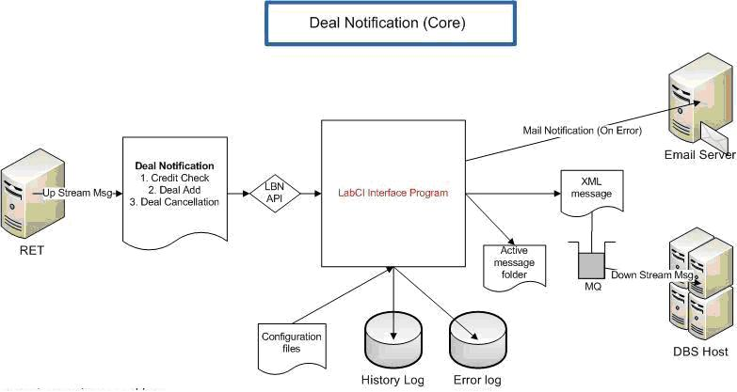

 | For PCE Limit Check
From RET to Murex | When there is a deal request submit to RET, RET will trigger a credit check request message called CA1. This message can be captured by the LBN API by event driven.  The purpose of this function is to check the limit maintained by Murex. Interface program will then pack the FXLimitVal XML message to IP for the processing.
From Murex to RET | If Limit does not breach in Murex, we will receive a credit check response message from IP layer. This Interface program will do the following:  If the response is credit check passed, it will call the corresponding LBNAPI method call to feedback the credit check response to RET. (CA2 in RET terminology)  If the response is credit check failure because of limit breached, it will capture and reformat the limit information returned by Murex and call the corresponding LBNAPI method to feedback the credit check response to RET and display the limit information in RET applets. (e.g. If credit failure is due to limit breach, it will display the limit information in RET applets for the user reference.  If the response is credit check failure because of other errors/faults, it will feedback the credit check response to RET and send the email notification to inform the corresponding support or BU team.  Note: Please refer to the section 6.3 Design Constraints for more details of the limitation of the interface program.

 | For Deal Addition
From RET to Murex | If the Credit Checking is passed, both T&M Sales or Dealer can carry on the completion of the FX deal. If the Sales desk accept the FX rates quoted by Dealers, they can click the confirmation button in RET applet. After that, the deal is treated as DONE in RET point of view. Please note that up to this moment, the deal is only complete in RET but not in Murex. (see IMPORTANT notes below.) When the deal is done in RET, RET will trigger another Deal Completion message called DO1. This message can be captured by the LBNAPI by event driven. DN Interface program will then further pack the XML message FXDealAdd and send to IP then Murex for the further processing.
From Murex to RET | 1. If the deal can be logged in Murex successfully, Interface program will capture the Murex reference number from the FXDealAdd message response and then call the corresponding LBNAPI to update this reference number to RET DB.  2. If there is any error caused the deal cannot be logged in Murex, Interface program will capture the error message from FXDealAdd message response and then send out the email notification to support team and BU for the action taken. Please note that there won’t be any automatic mechanism to cancel the related done deal in RET for this type of error.

 | For Deal Deletion
From RET to Murex | T&M Sales desk  When T&M Sales desk search the RET deal in RET applet, they have to input the following information in the RET cancel deal => Cancel reason:  1. Input Murex reference number of original deal.  2. Input the trader cost of the original deal  3. (Optional) Input the comments to the “Dealer Remark”  T&M Dealer desk  DN Interface program will suppress the credit check request if it is RET cancel deal Interface program will then capture latest trader cost from this “new” deal and further pack the XML message FXDealDel and send to IP then Murex for the deal deletion processing.
From Murex to RET | If there is any error returned from IP, Interface program will send mail notification to inform support team / BU for the action taken.

Outputs

For PCE Limit Check | Credit check pass or fail (both manual quoted deal and reversal new deal) in RET.  If credit check is passed, user can carry on to book the deal in RET. Otherwise, RET will prohibit the deal booking and prompt the credit check failure messages in the RET front end applet.
For Deal Addition | When user confirm the deal in RET. RET will further to book and log the deal in own database.  Such done deal should be further to pass to Murex.
For Deal Deletion | In RET, the deal will be marked as “Cancelled”.  In Murex, deal will be deleted.

Deal Input Customization – Trader Applet
RET to allow trader to input information when they book trades on behalf of counterparties.

Purpose of the Function
User friendly interface to book the trade to TZ and perform the limits check, if applicable to the deal type.

Input
No | Field | Condition | Region | Type | Length | Description | Example | Message Field Map
 | City-Branch code | Mandate | ALL | Drop-down list | N/A | Concatenate field  City code: Branch Code SOLID | Taichung-001 | 1. City Code => IP:<op:ContractCity>  TZ:CITY-CODE if CN/TW.  2. Branch Code => IP:<ems:OpMainUnit>  TZ:BRCH-CODE & IP:<ems:ProcMainUnit>  TZ:PROC-DEPT
 | Requesting Unit | Mandate | ALL | Drop-down list | N/A | The originator requesting unit | CBG  IBG-GTS Trade  IBG-GTS Cash {Default} | TZIA-INTF-SYS [X4]  CBG=RETC  IBG-GTS Trade=RETT  IBG-GTS Cash =RETI
 | Deal Deletion | Optional | ALL | Drop-down list | N/A | Indicator if the deal is meant for a deletion | Yes  No {Default} | N/A
 | Original Ref for Reversal | Optional | ALL | Text Box | 30 char | Applicable only if Deal Deletion is selected as YES.  Input TZ Ref No | Free text format | IP:<ems:DealRef>  TZ:DEAL-REF
 | Dealer Remarks | Optional | ALL | Text Box | 40 char | Free text format if Deal Deletion is selected as YES. | Free text format | IP:<op:DealerRemark>  TZ:DLR-INSTR
 | PCE Override Auth Code | Optional | ALL | Text Box | 10 char | Free text format for user to input the authorized code to over-ride for case where deal amount excess PCE Limit | Free text format | IP:<ems:AuthId>  TZ:APPROVING-OFFCR
 | Regulatory Compliance Code | Conditional Optional | CN & ID | Text Box | 8 char | Applicable only for China & Indo.  Free text field to input the PBOC/SAFE code[China] and transaction code [Indo] | Free text format | IP:<op:FieldName>  TZ:PRC-PBOC
 | Customer/Beneficiary Type | Conditional Optional | CN & ID | Drop-down list | N/A | Applicable only for China & Indo. | B - Cross Border (CN)  C – DBS Customer (ID)  X – Non-Customer (ID/CN)  N-Not Applicable[Default] | IP:<op:FieldName>  TZ:CUST-TYPE3
 | Entity Indicator (TW) | Conditional Optional | TW | Drop-down list | N/A | Applicable only for TW  Indicator for Overseas business Unit/ Domestic Business Unit. | D – DBU [Default]  O – OBU | IP:<op:ReportDetl>  TZ:TW-DBU-OBU
 | Deal Purpose | Optional | TW & CN | Text Box | 40 char | Applicable for TW & China  For China:  e.g. Extension of TF10000131-01  e.g. Fully early settle of TF10000132-01  For Taiwan:  e.g. Pre-fixed  e.g. Rollover of TF10000133-01  e.g. Early termination of TF10000134-01 | Free text format | IP:<op:CustInstr>  TZ:CUSTOMER-INSTR

Please refer to below attachment for HK input fields.
Error! Not a valid link.

Processing Logic and Conditions
Refer to the table above.
- The system will prompt the user if there is error in the validation.
- Please note that comma is not allowed as an input character.
- For those fields which are conditional optional will be NOT be displayed to the users based on the user’s entity.

Outputs
Refer to Section 6.1.5 - Interface to Murex – Deal Notification

Email Notification

Purpose of the Function
No | Scenario | Recipients
 | Any rates movements which meet the board rate conditions | Pre-defined user groups
 | Any deal booked via RET Trader Applet. | Refer to table Table 6.1.7.1a/b below for different countries setup.
 | Any deal from RET but failed to booked in Murex. | - T&M user group mail (if set)  - Country BMS IT support Group (if set)  - RTT RET Support Team
 | Technical errors such as  - If any fault message responses from IP indicate there is a failure from TZ, this interface program should send out the mail notification to Support team (e.g. RTT RET team or SDM team) immediately.  - If any fault message responses from IP indicate there is a rate sync failure for any DS (RU, IMEX or Finacle), this interface program should send out the mail notification to Support team (e.g. RTT RET team or SDM team) immediately. | - RTT RET Support Team  - SDM team (if set)
 | Deal Deletion via RET Trader Applet. | Refer to table Table 6.1.7.1a/b below for different countries setup.

Table 6.1.7.1a - Email notification for deal booking in INDO/INDIA
Action | Customer Segment | Credit Limit override? | VSD deal? | Send to (production)
Deal Creation | CBG/IBG | Yes | Yes | - Credit Approver  - T&M group mail  - CBO/IBG Ops group mail
Deal Creation | CBG/IBG | No | Yes | - T&M group mail  - CBO/IBG Ops group mail
Deal Creation | CBG/IBG | Yes | No | - Credit Approver  - T&M group mail  - TMO group mail
Deal Creation | CBG/IBG | No | No | - T&M group mail  - TMO group mail
Deal Deletion | Any | N/A | N/A | - T&M group mail  - RTT RET App Support

Table 6.1.7.1b - Email notification for deal booking in Taiwan & China
Action | Customer Segment | Credit Limit override? | Send to (production)
Deal Creation | IBG | Yes | - T&M user who submit the deal on behalf of customers  - Credit Approver  - T&M group mail  - IBG Ops group mail
Deal Creation | IBG | No | - T&M user who submit the deal on behalf of customers  - T&M group mail  - IBG Ops group mail
Deal Creation | Non-IBG | N/A | - T&M user who submit the deal on behalf of customers  - CBG Ops group mail (if set)
Deal Deletion | IBG | N/A | - T&M user who submit the deal on behalf of customers  - RTT RET App Support  - T&M group mail (if set)  - IBG Ops group mail (if set)
Deal Deletion | Non-IBG | N/A | - T&M user who submit the deal on behalf of customers  - RTT RET App Support  - CBG Ops group mail (if set)

Processing Logic and Conditions
Not applicable

Outputs
An email sent to the target recipient group.

The actual email format and template will be reviewed during UAT.

Reports

Purpose of the Function
To create the reconciliation reports to send to Murex so as to reconcile deals done in RET and Murex.

Input
Deals created via RET.

Processing Logic and Conditions
To connect to RET database to retrieve the deals
- By entity. Deals for a certain region are to be extracted only. Eg ; TW, ID
- Reporting Date. All deals done in RET for this current date will be extracted out.

It will be the consolidated accumulative deals done for the day. Murex will handle the reconciliation.
Example
1st File Deal 1 to 100
2nd File Deal 1 to 200

Outputs
Refer to Murex/TZ Reports

User Authentication - Integration with AD

Purpose of the Function
To provide user authentication using Active Directory.
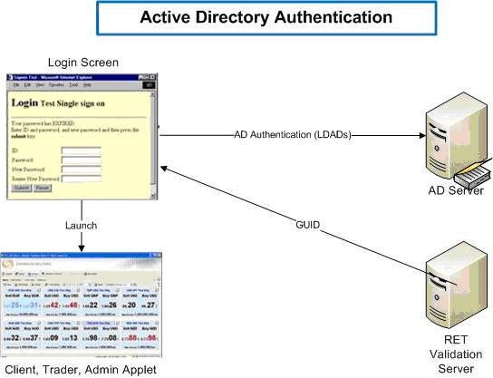

Input
User ID (1bankID)
Password
Domain
Account

Processing Logic and Conditions
The login request will then send by a java servlet. The servlet will initiate the LDAP protocol and perform the AD Authentication.
  - If AD authentication success, then servlet will further send the request to RET validation server for the GUID. This GUID will be used to login and launch different type of RET applet.
  - If AD authentication fails, then servlet will redirect to an error page and display the corresponding error.

Outputs
If authentication success, RET applets will be launched. Otherwise, redirect user to the login failure page.

Note: The client workstation should meets the minimum system requirement to run the applet.

User Maintenance - Integration with AIM

Purpose of the Function
For any staff accounts that need to be created in RET, the interface program should enable the creation/modification/deletion of accounts in RET, thereby enabling STP.

Input

Processing Logic and Conditions
Addition | Modification | Deletion
- Add a new staff id(ibankid) in RET (set Full name, set Type, set Email, set Mainframe ID)  - Add the newly created ibankid (staff id) into the existing RET User Group.  - Generate Status file indicating success and failure of account and reason of failure with error code specific to AIM. File to be sent over to AIM via secure copy (scp). | - Modify existing user profile in RET. Reset Full name, Type, Email, Mainframe ID if any change to any of the fields.  - If User group is changed, move the user with all the credentials from one group to another existing group.  - Generate Status file indicating success and failure of account and reason of failure with error code specific to AIM. File to be sent over to AIM via scp. | - Disable the user’s account, such that no trade can be done with this id.  - Generate Status file indicating success and failure of account and reason of failure with error code specific to AIM. File to be sent over to AIM via scp.

Outputs
Staff account created in RET with correct setup:
    - Staff id (1bankid) imported to the correct Group, with all the necessary details.
    - Status file generated for AIM processing.

Non Functional Requirements

Refer to a separate document DBST820 Non-FS.Regional RET_v1.2 in share folder below for etails.
- \\10.190.17.19\sdm\RET-TZ-Project\04-02 Requirements\Non-Functional Requirements\

Design Constraints
This section should indicate any design constraints on the system being built. Design constraints represent design decisions that have been mandated and must be adhered to. Examples include software languages, software process requirements, prescribed use of developmental tools, architectural and design constraints, purchased components, class libraries, etc.

RET Interface Programs
- The whole interface program will be written by Java and Unix scripts
- Build file is highly recommended and stated clearly about the supported Java version.
- The interface program should not limit to any development tools.

RET TrAPI Constraint
The RFQ uses the RET trAPI, which is a Java API provided by Reuters to subscribe to and get the update for FX rates. Since there is only one user login to RET, the RFQ will get FX rate for different currency pairs, customer segments…etc sequentially rather than simultaneously.

Tomcat Server Constraint
The RFQ web service is running in Tomcat v6.0 open source server, the capacity of RFQ to handle the incoming requests concurrently will be depended on the capacity of the Tomcat server.

Deal Notification
- This is interface program which does not cater for any RET Applet GUI change.
- RET, MLC, Murex & TZ are completely separated systems. The workflow of the deal creation/cancellation is always done in RET first and then pass to Murex. This is the core logic of LBNAPI.
- If there is a need to perform checking before doing the deal, the ONLY way to do is via Credit Checking logic.

RET Reporting
- The whole reporting interface program will be written by Java.
- Trades done is limited to deals done in RET only.

Trader Applet Customization
- The whole interface program will be written by Java.
- The customization fields are constraint by the Database table data.
- Limited fields are allowed to be displayed on the Trader applet. Recommended by Reuters, 10 fields maximum.

Outstanding Items
Not applicable. This section is left blank intentionally.

User Documentation and Help System Requirements
Describes the requirements, if any, for user documentation, help systems, help about notices, etc. Also include the user documentation standards as agreed with customer.

Requirement One
NA

Back-up and Recovery
This section should include the backup and recovery requirements. This will include the back-up media, data files, frequency, cycles and retention periods. Contingency planning and the recovery strategy in emergency situations should also be noted.

Adhere to standard bank level back-up and recovery process/procedures.

Purchased Components
This section describes any purchased components to be used with the system, any applicable licensing or usage restrictions, and any associated compatibility and interoperability or interface standards.

Not applicable. This section is left blank intentionally.

DR / BCP Requirements

No specific user requirement for DR or BCP.

System Interfaces
The interfaces to other systems, be they for in-house or external entities are to be specified in this section. It may be useful to put this information in a table specifying the source and destination, frequency, size and processing window.

Board Rate Sync

Source & Destination of Interface Function
Source: RET via programming API (TrAPI)
Destination: IP via MQ (In XML format)

Interface Format

Processing
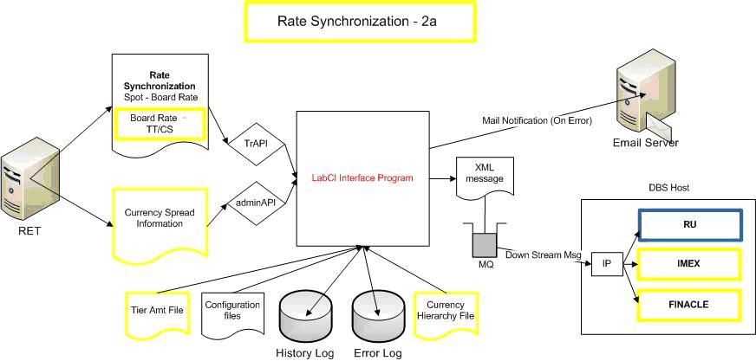

Timing & Conditions
Refer to Section 6.1.1 - Board Rate Publishing

RFQ Interface

Source & Destination of Interface Function
getFXrate is a method provided by RFQ service to retrieve the FX rate from RET

Interface Format

Processing
RFQ service is designed to run one service for each country, different country will have different URL to be connected with. These URL will be:
Country | RFQ URL
Taiwan | http://hostname:port/rfq/dbstw/FXrate
Indonesia | http://hostname:port/rfq/dbsid/FXrate
China | http://hostname:port/rfq/dbscn/FXrate
Hong Kong | http://hostname:port/rfq/dbshk/FXrate
India | http://hostname:port/rfq/dbsin/FXrate

The high level class diagram will be as follows.
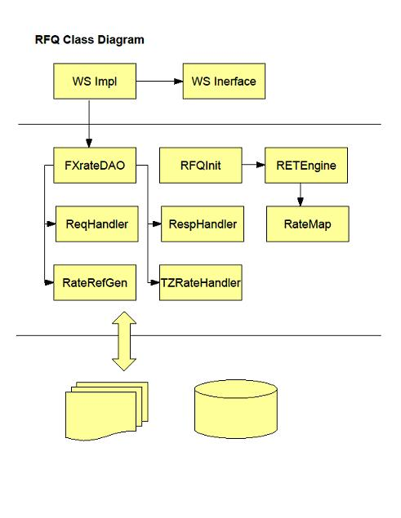

Figure ‎6-5 RFQ Class Diagram

This table describes the functionality of each class in the class diagram
Class Name | Description
WSImpl and WSInterface | 1. Web service interface java class  2. Web service implementation class
RFQInit class | RFQInit will initialise the following and run once only  1. Load in the RET ccy pairs  2. Init Trapi/Admin API  3. Load in the amt and users tier  4. Subscribe the RET ccy pairs based on amt/users tier
FXRateDAO class | 1. Call ReqHandler to validate RFQRequest  2. Call ReqRateMap to convert the RFQRequest to Key in rateMap  3. Retrieve rates from RETRate  4. Call TZRateHandler to send cover rate to TZ  5. RespHandler to construct the RFQResponse
ReqHandler class | 1. Validate the RFQRequest  2. Add in the component rates if RFQRequest is for cross ccy  3. return the arraylist of the rate request
ReqRateMap class | 1. Convert the rate request based on amt tier and user  2. Map the rate requests into key in rateMap  3. Retrieve the RETrate from rateMap
TZRateHandler class | 1. Get RETrates including component rates  2. Form the TZ message  3. Send the cover rate message to TZ
RespHandler class | 1. Get RETrates including component rates  2. Construct RFQResponse java bean based on the RETrates  3. Return the RFQResponse
RateRefGen class | 1. To generate the unique rate ref number

Table 5 RFQ Class Description

Timing & Conditions
To confirm the timing allowed for RFQ

CNY.USD Valuation – Trading Band

Source & Destination of Interface Function
Source: RET rates via TrAPI
Destination: RET rates via FIAPI

Interface Format
Not applicable.

Processing
Not applicable.

Timing & Conditions
Whenever there is rate to be published to requestor

Customer Profile Upload

Source & Destination of Interface Function
- File from Finacle to be CD’ed over to RET server.
- Finacle interface file is a fixed length file. Seven fields from Finacle Interface file will be used and they are: CIF-ID, CST- NAME, Segment Code, Country Code, Customer Tier#, Record Status.
- refer to the CIF interface structure for the master file proposed by Finacle.
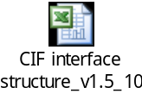

Interface Format

Processing

Timing & Conditions

Interface to Murex - Deal Notification

Source & Destination of Interface Function
Source: RET via programming API (LBNAPI)
Destination: IP via MQ (In XML format)

Interface Format
Refer to the Message format in TZ CommArea
- Credit Check FXLimitVal Message
- Deal Addition Deal Add Message
- Deal Deletion Deal Deletion Message

Processing
Refer to Section 6.1.5 Interface to Murex – Deal Notification

Timing & Conditions
- Credit Check During Deal Creation
- Deal Addition During Deal Creation
- Deal Deletion During Deal Deletion

Deal Input Customization – Trader Applet

Source & Destination of Interface Function
Source: CustomFields API
Destination: IP via MQ (In XML format)

Interface Format
Not applicable.

Processing
Not applicable.

Timing & Conditions
Not applicable.

Email Notification

Source & Destination of Interface Function

Interface Format

Processing
Not applicable.

Timing & Conditions
Not applicable.

AIM Interface

Source & Destination of Interface Function
Source: Interface file from AIM
Destination: RET (via AdminAPI)

Interface Format
Refer to AIM for the actual layout.
Interface file: pipe ‘|’ delimited format

Processing
Not applicable.

Timing & Conditions
- Mass user creation for the first launching via script
- Daily upload after day-1.
- Actual timing for the interface file transfer from AIM will be handled by the TWS.

AD Interface

Source & Destination of Interface Function
Source: RET via programming API (Validation API)
Destination: AD via LDAPS

Interface Format
Not applicable.

Processing
Not applicable.

Timing & Conditions
- Trigger upon user logins
- As long the RET Web is up and running.

Reports

Source & Destination of Interface Function
Source: RET via database
Destination: Murex via ConnectDirect

Interface Format
Refer to Murex Reports Format.

Processing
Extracts the deals created within RET for the respective entities.
This reporting interface program will only send N reconciliation reports to Murex at each agreed time during the day.

Timing & Conditions
The frequency of sending of reports is dependent on reports generations in Murex and can be configured via TWS scheduler.

User Interfaces

The user interface is adopted from Thomson Reuter’s standard applet except for the trader applet which is customized to facilitate the inputs of the trade. Refer to Section 6.1.6 Deal Input Customization – Trader Applet for details. Refer to the Reuter’s RET user guide for the usage of standard RET applet.

Admin Applet
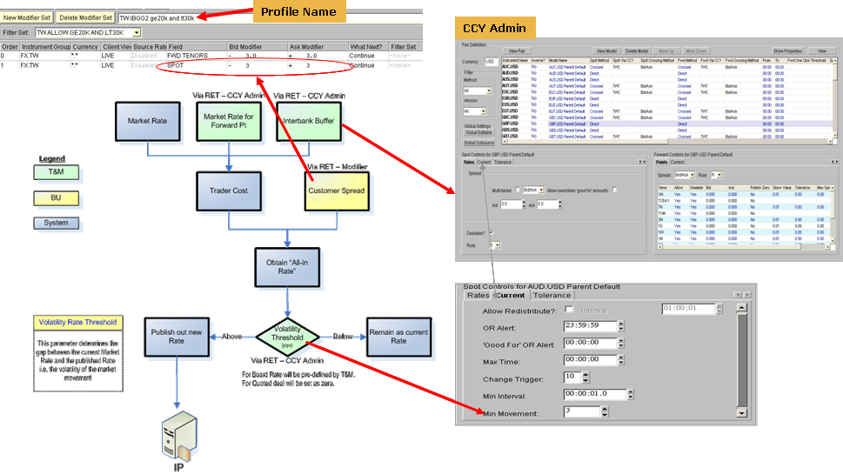

BMS country admin can only change the settings for their own country. BMS country admin access rights shall be defined by BMS Singapore as a super admin users of the RET.

Trader Applet

Outright Input screen (For VSD, SPOT, FORWARD)
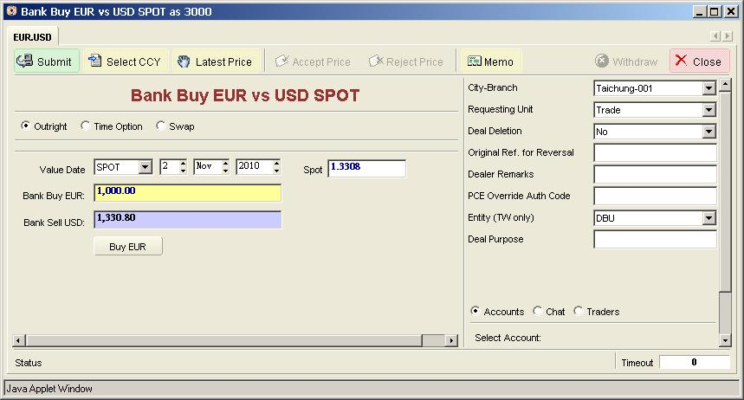

Time Option Input Screen
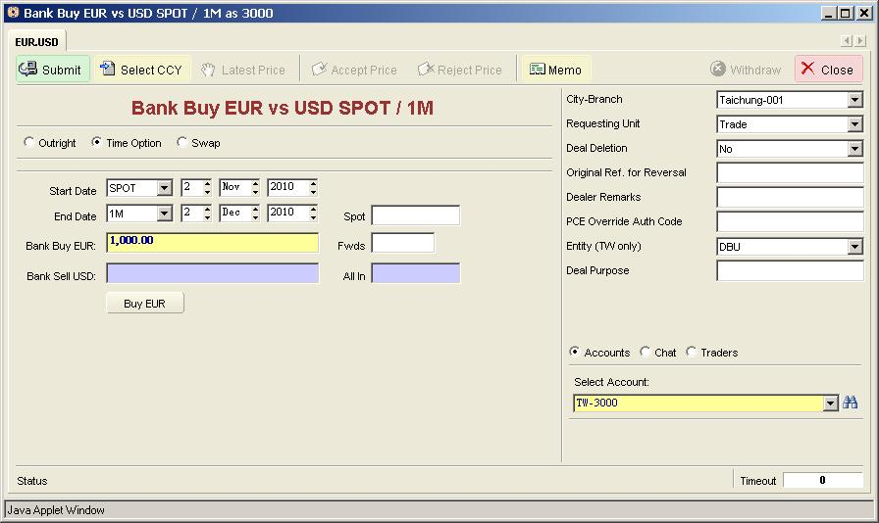

SWAP Input Screen
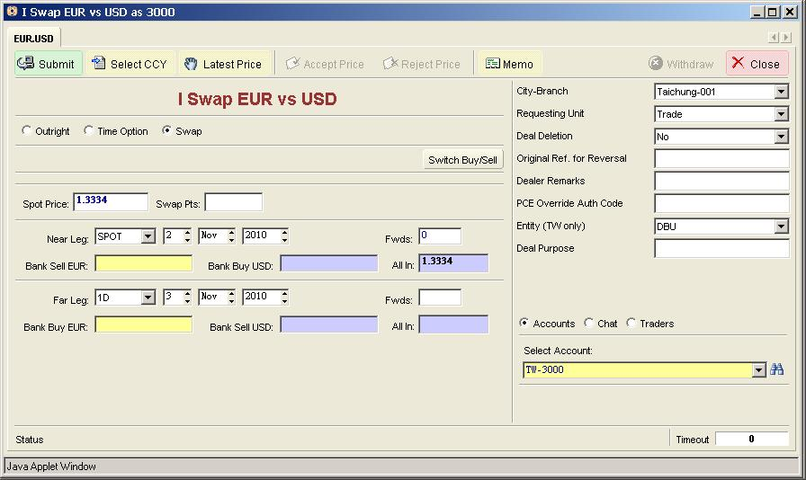

Early Take up Input Screen (Full/Partial)

Data Requirements
List any specific data requirements in this section. This may include a description of the data type, format, accuracy, data security, data availability (when and how often access is given), data currency (frequency and timing of refresh), data granularity (level of detail and summary) and data flows, that are required.
It is also recommended that the method for ensuring that data quality is maintained is documented or referenced from here.
Include any references to any supporting information for e.g. CRUD Matrix (Create, Read, Update, Delete), Data Quality Plans, etc.

Data Requirement One
The requirement description goes here.

Reference Code Requirements
List any specific reference code requirements in this section. This may include a description of the reference code type, format, availability (when and how often access is required), currency (frequency and timing of refresh), and data flows, that are required.
It is also recommended that the method for ensuring that reference code quality is maintained is documented or referenced from here.
Include any references to any supporting information for e.g. CRUD Matrix (Create, Read, Update, Delete), Data Quality Plans, etc.
Please describe the reference code requirements using the following table:
(refer to user reference code governance policy for reference code classification)
Reference Code | Reference Code Classification  (E<nterprise>,  C<ountry>,  A<pplication>,  U<nknown at this point) | Reference Code Requirement  (N<ew value for an existing code list/  new reference code list required >,  A<mendments to an existing value>, D<elete an existing value) | Additional details
Eg1. Marital Status | U | A | Change existing value from U to NA
Eg2. Country code | E | N | New field required for capturing of country of residence
Eg3. Customer owner | U | N | New value required for IBG4

Archiving and Retrieval Requirements
This section should state the archiving and retrieval requirements. Include the type and location of data,, the number of weeks that the data needs to be online for and the number of years it must be kept in archive. Specify the number of hours within which the archived information must be made available from the time a retrieval request is made. It may be useful to present this information in a table.

The system will follow the bank’s standard retention and backup policy.

For the online data inquiry within the RET database will set as 3 calendar months for each entity.

Conversion Requirements
Specify how existing data is to be converted and inputted to the system.
The preferred conversion approach, manual or automatic should be highlighted. Depending on the requirement of the system, re-classification of existing data should also be specified.
Counterparties will be migrated from Finacle to RET before the RET system is go live for each country.

Details please refer to the data migration document for corresponding country.

Data Group Name

Group of Data
Define the group of data to be converted.
Specify the type of data in the group whether the data is static or dynamic.

Conversion Approach

Mapping Criteria
Specify how the existing data is to be converted and interpreted in the future system.

Converted Data
Specify the format and attributes of the converted data.

Entity Relationship Diagram
Identify the business entities and their attributes that the user will need to manipulate or record data about. This section should include a relationship diagram including entity definitions and a description of the processes performed on these entities. An entity can be a person, place, thing or concept for e.g. (Customer, Address, Order or Transaction). Attributes are details about a specific entity and provide greater clarification about the data that can be captured about that entity e.g. some of the attributes of the Customer entity could be (Name, Age, Date of Birth, Occupation, Marital Status, Race, etc).

Not applicable. This section is left blank intentionally.

Licensing Requirements
Defines any licensing enforcement requirements or other usage restriction requirements that are to be exhibited by the software.

Reference to the Addendum to the Trading Rental Solutions Agreement, “REUTERS ELECTRONIC TRADING FOR AUTOMATED DEALING DEPLOYED VERSION - SOFTWARE LICENSE ORDER FORM USER BASED BILLING (RENTAL)”

Applicable Standards
This section describes any applicable standards that apply to the system being described. For example, this could include legal, quality and regulatory standards, industry standards for usability, interoperability, internationalization, operating system compliance, etc.

Not applicable. This section is left blank intentionally.

References

Procedures
Provide a bulleted list of any procedures referred to in this plan. Use the format:
- Procedure for Project Planning (AMSP491)

Plans and schedules
- Provide a bulleted list of any plans or schedules referred to in this plan.

Other references
This subsection should provide a complete list of all documents referenced elsewhere in the functional specification. Each document should be identified by title, report number (if applicable), date, and publishing organization. Specify the sources from which the references can be obtained. This information may be provided by reference to an appendix or to another document. Provide a bulleted list of the other references or enter the following text:
There are none.

End of document– AMST573: Functional Specification

- Different threshold rates to be applied by entities. To be agreed and confirmed by Business.
- Customer Group setup as per Finacle
Branches/IBG Ops
T&M
Sales Desk
Branches/IBG Ops
phone call
Branches/IBG Ops
T&M
Sales Desk
Update Position
STEP 4
Accept Rate &
Confirm Deal
STEP 3
Provide Rate
Request
for Rate
STEP 2
STEP 1
Manual
Quote
Auto
Quote
Board
Rate
Threshold A
Threshold B +
Customer Group*
Threshold C
Same
Day
Value
Immediate
Batch Deals Based on CCY Pair & Threshold
System auto quote based on latest Market Rate
Confirm via Product Processors
Display last available Board Rate
Input via the Front-end of the Product Processors

Immediate
Input & Confirm via RET Client
Calculate Rate based on latest Market Rate
Call T&M
Sales Desk
Forward Value

